

Programul de studii:
Informatica Aplicata în Limba Germana

Lucrare de licență

Explorând Utilitatea Interfețelor Vocale în Transportul Public: O Analiză a Unui Skill Alexa

Autor: | Florian Chițu
Coordonator ştiințific: | Conf. Dr. Livia Sângeorzan  Asist. Drd. Dragoș Tohănean

Braşov, 2023

Table of contents

Paper Structure 3
1. Introduction 4
2. Chapter 2: Personal Contributions to the Field 6
2.1 Development of a User-Oriented Alexa Skill: 6
2.2 Creation of a Custom REST API in ASP.NET 7
2.3 Integration of Alexa Skill and .NET API 8
2.4 Using Serverless Architecture for Scale and Efficiency 8
2.5 Contributions to Microservices and Cloud Computing 8
2.6 Pushing the Boundaries of Voice User Interface (VUI) 8
3. Chapter 3: Research Methodology 1
3.1 Understanding User Requirements 1
3.2 Applied Research Methodology 1
3.3 Trends in the Use of Voice Interfaces 2
3.4 Comparing the Voice Interface (VUI) with the Graphical Interface (GUI) 5
4. Chapter 4: Internet of Things (IoT) and Its Applicability in Public Transport 9
4.1 Exploring IoT Technology 9
4.2 Advantages and Challenges of Using IoT in Public Transport 10
4.3 The Rise of Voice Assistants and their Increasing Popularity 11
4.4 Future Directions in Researching the Use of IoT in Public Transport 16
5. Chapter 5: Analysis of the Amazon Alexa Ecosystem 16
6. Chapter 6: Presentation of the Developed Application 17
6.1 Vision and Objectives of the Application 17
6.2 System Architecture 17
6.3 User Interface (UI) and User Experience (UX) 22
7. Chapter 7: Technologies Used in Application Development 24
7.1 Using ASP.Net 24
7.2 Using Node.js 30
7.3 Alexa Skill Kit 31
7.4 Cloud – Amazon Web Services 32
8. Chapter 8: The Development Platform 32
8.1 Visual Studio 32
8.2 VS Code 33
8.3 Amazon Alexa Developer Console 34
8.4 Microsoft Sql Server 35
9. Chapter 9: Application Development and Implementation – 15 pagini 36
9.1 Application hardware components 36
9.2 Application Development Process 38
9.3 Structure of the database 46
9.4 Application User Guide 48
10. Chapter 10: Future Development Perspectives 49
11. Conclusion 50
11.1 Concluzie 51
Bibliography 53

Cuprins

Structura lucrarii .1
1.Introducere 1
2.Capitolul 2: Contribuții personale în domeniu 2
2.1 Dezvoltarea unui Skill Alexa orientat către utilizator……………………………………………………………….2
2.2 Crearea unui API REST personalizat în ASP.NET………………………………………………………………………..2
2.3 Integrarea Skill Alexa și a API-ului .NET…………………………………………………………………………………….3
2.4 Utilizarea unei arhitecturi serverless pentru scalabilitate și eficiență……………………………………….4
2.5 Contribuții la microservicii și cloud computing…………………………………………………………………………4
2.6 Depășirea limitelor interfeței utilizator prin voce (VUI)……………………………………………………………4
3. Capitolul 3: Metodologia de cercetare 4
3.1 Înțelegerea cerințelor utilizatorului………………………………………………………………………………………….4
3.2 Metodologia de cercetare aplicată ………………………………………………………………………………………….1
3.3 Tendințe în utilizarea interfețelor vocale………………………………………………………………………………….1
3.4 Compararea interfeței vocale (VUI) cu interfața grafică (GUI)………………………………………………….5
4.Capitolul 4: Internetul obiectelor (IoT) și aplicabilitatea acestuia în transportul public 9
4.1 Explorarea tehnologiei IoT……………………………………………………………………………………………………….9
4.2 Avantajele și provocările utilizării IoT în transportul public……………………………………………….……10
4.3 Creșterea asistenților vocali și popularitatea lor în creștere…………………………………………….…….11
4.4 Direcții viitoare în cercetarea utilizării IoT în transportul public……………………………………………..16
5. Capitolul 5: Analiza ecosistemului Amazon Alexa 16
6. Capitolul 6: Prezentarea aplicației dezvoltate 17
6.1 Viziunea și obiectivele aplicației……………………………………………………………………………………………..17
6.2 Arhitectura sistemului……………………………………………………………………………………………………………17
6.3 Interfața utilizator (UI) și experiența utilizatorului (UX)………………………………………………………….22
7. Capitolul 7: Tehnologiile utilizate în dezvoltarea aplicației 24
7.1 Utilizarea ASP.Net…………………………………………………………………………………………………………………24
7.2 Utilizarea Node.js 30
7.3 Alexa Skill Kit 31
7.4 Cloud – Serviciile Amazon Web 32
8. Capitolul 8: Platforma de dezvoltare 32
8.1 Visual. 32
8.2 VS Code 33
8.3 Consola dezvoltatorului Amazon Alexa 34
8.4 Microsoft Sql Server 35
9. Capitolul 9: Dezvoltarea și implementarea aplicație 36
9.1 Componentele hardware ale aplicației 36
9.2 Procesul de dezvoltare a aplicației 38
9.3 Structura bazei de date 46
9.4 Ghidul utilizatorului aplicației 48
10. Capitolul 10: Perspective de dezvoltare viitoare 48
11. Concluzie 49
Bibliografie 50
Anexa A1: Studii existente …………………………………………………………………………………………….54

List of Figures

Figure 1 High-level Alexa Architecture: Users and Skill Developer……………………………5
Figure 2 Conversational user interface 7
Figure 3 Backend Arhitecture Project Structure 18
Figure 4 Domain Layer folder structure 18
Figure 5 Data Acces Layer folder structure 19
Figure 6 Aplication Layer folder structure 20
Figure 7 Handlers on client side 20
Figure 8 Lambda Function on AWS Platform 21
Figure 9 Backend Lambda communicating with the API to a bridge 21
Figure 10 Client Lambda communicating with Alexa service 21
Figure 11 Alexa Microservices Architecture 22
Figure 12 Natural model language. 23
Figure 13 Minimal API simplified syntax 28
Figure 14 Supported versions 28
Figure 15 NET 6.0 LTS release………………………………………………………………………………….29
Figure 16 Visual Studio Control Panel 33
Figure 17 Vs Code Alexa Skill Kit Extension that support application development and testing 34
Figure 18 Alexa Developer console and the features via Tabs 35
Figure 19 Alexa Echo Show 36
Figure 20 Intents in Alexa Developer Console 40
Figure 21 Dialog Model with 216 utterances 41
Figure 22.1 Handler that provides the time until the next bus arrives 43
Figure 23.2 Handler that provides the time until the next bus arrives 44
Figure 24 Database Schema 47

List of Tables

Table 1 Number of voice assistan users 13

Table 2 Percentage of people using different digital assistants 13

Paper Structure

Chapter 1: Introduction - The chapter provides an overview of the choice of theme, highlighting its theoretical and practical importance, the innovations it brings and the general objectives of the paper.

Chapter 2: Own Contributions to the Field - This chapter highlights the author's unique contributions to the field.

Chapter 3: Research Methodology - The chapter describes the research methods used, data collection tools and analyzes current trends in the use of voice interfaces compared to graphical interfaces.

Chapter 4: Internet of Things (IoT) and its applicability in public transport - The chapter explores IoT technology, discusses the advantages and challenges of its use in public transport and examines future research directions in this context.

Chapter 5: Overview of the developed application - This chapter presents the developed application in detail, from its vision and goals, to architecture, functionality, integrations and machine learning process, as well as aspects related to security, privacy and feedback and improvement mechanisms.

Chapter 6: Technologies Used in Application Development - The final chapter discusses the techniques and technologies used to create the application, including ASP.Net, Node.js, Alexa Skill Kit, Amazon Web Services, and Microsoft SQL.

Chapter 7: The Development Platform – This chapter details the software development tools used in the application creation process, namely Visual Studio, VS Code, and the Amazon Alexa Developer Console.

Chapter 8: Application Development and Implementation - This chapter focuses on the technical aspects of making the application, including the hardware components, the development process, the database structure, and a guide to using the application.

Chapter 9: Conclusions and Prospects for Future Development - This last chapter concludes the paper by presenting the conclusions drawn from the research carried out and discusses possible directions for development and improvement of the application in the future.

Introduction

In the digital age we live in, efficiency and ease of access to information have become imperative. In an alert and busy life, people expect all the data they need to be at their fingertips, fast and easy to access. In particular, information related to public transport - an essential element of urban life - must be available at all times.

However, in stressful situations or when time is of the essence, accessing information through traditional means such as websites or mobile apps can be a slow and frustrating process. Thus, inspired by a personal experience, I decided to deepen a solution that would make this process more efficient and facilitate access to public transport information.

This paper aims to develop a specific Alexa application that demonstrates the utility and efficiency of voice interfaces in the field of public transport. Alexa, developed by Amazon, is one of the most popular voice assistant technologies available today. Offering a robust feature set and broad integration with other devices and services, Alexa is an ideal platform for developing such an application.

The application I propose is not limited to being a simple means of obtaining information about bus schedules. By integrating with a cloud-based data management system, the app will be able to provide updated information in real time, remember user preferences and customize responses based on them. Thus, the application will be not only an information tool, but also a personal travel assistant.

By implementing this application, I aim to demonstrate that voice interfaces can play a crucial role in improving the experience of using public transport. They can make information more accessible and easier to understand, reduce the time needed to obtain information and contribute to a more pleasant and efficient travel experience.
The scientific relevance of this work can be appreciated from two essential perspectives.
First, the research sits at the intersection of two rapidly growing and increasingly important areas of study—voice interfaces and public transportation. Voice interfaces, represented by digital assistants such as Alexa, Siri or Google Assistant, constitute a revolutionary field that continues to develop and diversify. The effects of their transformation on human-machine interaction are still being analyzed and interpreted, which makes this field of study particularly relevant and full of potential. Applying this technology in such a practical and ubiquitous context as that of public transport represents an important step in exploring and understanding the real potential of voice interfaces.
Second, the paper aims to highlight the power and flexibility of cloud technology and microservices. These concepts, while not new, continue to be central to modern application architecture and development. By using Amazon Web Services (AWS) to host the Alexa application and .NET API, the paper demonstrates how cloud-based solutions can facilitate the development of scalable and efficient services. This approach provides the opportunity to focus on application development and optimization instead of dealing with the infrastructure and maintenance issues that come with running your own server.
In addition, adopting a microservices-based model allows a clear separation of responsibilities and facilitates the development, improvement or repair of individual application components without disrupting the operation of the system as a whole. This has a direct impact on the durability, availability and reliability of the system. The introduction of voice assistance technology such as Alexa, Siri or Google Assistant marked the beginning of a new era in human-computer interaction. According to estimates, by 2024 the number of devices with smart voice assistants is expected to exceed 8.4 billion, a number larger than the world's population. Therefore, the research and development of applications using the voice interface is not only current, but also vital for the next generation of technology.

With the help of speech recognition and natural language understanding technologies, these interfaces allow users to interact with their devices in a more natural and intuitive way. In contrast to traditional graphical interfaces, which require visual navigation and physical interaction, voice interfaces allow users to access functions and information simply by verbally speaking commands. This is especially useful in situations where users cannot or do not want to use their hands or eyes to interact with their device.

In the context of public transport, this type of interface can bring significant benefits. Users can quickly find out the bus schedule without having to use their mobile phone and navigate through apps or websites. In addition, by implementing such a solution in the public transport network, one can contribute to improving accessibility for people with visual or motor impairments.

Through this paper, I aim to contribute to this burgeoning field of research by exploring the application of voice interfaces in public transport. My objective is to develop a solution that is not only functional and efficient, but also easy to use, thus contributing to increasing the quality of public transport services and improving the user experience. In this context, I believe that voice interface technologies represent an important step in the future of human-machine interaction, and I hope that this work will demonstrate their potential and value in practical applications.

In terms of novelty, while there are already transportation apps that provide real-time information, this would be one of the first apps to use a voice interface to provide that information.
The overall objectives of this work are to develop, implement and test a system that combines voice interface technology with the power and flexibility of cloud-based solutions in order to facilitate access to public transport information. Through this, the paper hopes to demonstrate the potential of these technologies in solving practical problems and contribute to the development of more efficient and accessible public transport.

Chapter 2: Personal Contributions to the Field
In this chapter, I will detail the individual contributions I have made to the field through the development of my Alexa skill and ASP.NET Rest API.

Development of a User-Oriented Alexa Skill:
One of the most significant contributions I made during this project is the development of a user-centric Alexa skill tailored to provide real-time public transportation information. The cornerstone of this application lies in its ability to enhance the overall user experience by making crucial information readily available, thereby expanding Alexa's utility and democratizing access to public transportation.

The real-time nature of this Alexa skill sets it apart, as it's designed to provide current information about public transportation schedules. This immediacy is critical in the dynamic environment of public transportation, where schedules can often fluctuate due to varying factors like traffic conditions, mechanical issues, or weather disturbances. The ability to access real-time updates about public transportation timings can help users better plan their travel, thus saving them time and reducing uncertainty.

The user-friendly aspect of this Alexa skill is another of its key strengths. By utilizing voice interactions, users can receive necessary transportation details without having to navigate through complex interfaces or web pages. The simplicity of voice commands aids in making the system more approachable for a wide range of users, including those who may find traditional graphical user interfaces daunting or inaccessible.

Additionally, the hands-free nature of the Alexa skill offers a significant advantage, particularly for individuals in scenarios where using a handheld device is inconvenient or unsafe - for example, when they are carrying luggage, when their hands are occupied, or when they are already in transit. The ability to merely ask Alexa for the needed information simplifies the process of getting real-time public transport updates, making the experience more efficient than conventional methods.

In essence, the creation of this user-oriented Alexa skill fosters accessibility by bringing real-time public transportation information to users' fingertips (or rather, their voice commands). It represents a significant stride in utilizing voice-assistant technology to streamline everyday tasks, making public transportation more accessible, efficient, and user-friendly.

Creation of a Custom REST API in ASP.NET
The decision to construct my own REST API in ASP.NET for this project stemmed from a multifaceted motivation: to delve deeper into the mechanics of API development, comprehend best practices, understand data flow, and familiarize myself with different architectural approaches. By embracing this challenge, I could ensure that the backend service was tailored to serve the specific requirements of the Alexa skill I was building.

There were several reasons behind opting for a custom-made API instead of consuming an existing one, such as one provided by the city's public transport authority. Primarily, this decision was driven by the desire to grasp the intricacies of API creation. Constructing an API from scratch provided me with an invaluable learning experience, from comprehending the structural essentials of an API to connecting it with a SQL Server database. It also offered me a hands-on opportunity to put the theoretical knowledge I had garnered into practice.

In addition, privacy concerns and potential access limitations often pose significant obstacles when trying to use an existing API, particularly one controlled by a public institution like a city's transportation authority. These entities often have strict policies and restrictions regarding the use of their data, which could potentially limit the flexibility and functionality of the developed application.

Creating my own REST API also meant I could ensure robustness and security, tailoring it to the specific needs of the Alexa skill and guaranteeing seamless integration. Furthermore, the custom API could be optimized for performance and built to handle the specific request types and data structures that the Alexa skill would use.

By designing and controlling the API architecture, it's feasible to modify data access and processing rules at any time, depending on changing requirements or conditions. This flexibility is crucial in the ever-evolving technological landscape where requirements and best practices can change rapidly.

The API's structure was developed with this adaptability in mind, ensuring that changes in data access or data handling protocols could be readily accommodated. For instance, if the data source for public transportation schedules were to change, the API could be quickly and efficiently updated to interact with the new source, while still providing consistent service to the Alexa skill.

Lastly, deploying the API on AWS as a serverless application not only allowed for greater scalability but also provided a significant learning experience in cloud deployment and serverless computing. This approach reduced the need for ongoing server management and allowed me to focus more on core application development.

The creation of a custom REST API in ASP.NET was not only a necessity due to external constraints but also a conscious choice for learning and skill enhancement. This experience allowed me to better understand and appreciate the role and workings of backend services in creating efficient and user-friendly voice-activated applications.

Integration of Alexa Skill and .NET API
My work bridges the gap between Alexa skills and .NET APIs, demonstrating how they can communicate seamlessly. This could serve as a blueprint for other developers looking to integrate .NET services with Alexa skills.

Using Serverless Architecture for Scale and Efficiency
By deploying both the Alexa skill and .NET API as serverless applications in AWS, I have highlighted the benefits of serverless computing, including scalability, cost-efficiency, and ease of management.

Contributions to Microservices and Cloud Computing
Through my work, I've explored the practical application of microservices architecture in a real-world scenario. I have also shown how cloud services like AWS can be used for deploying and managing these microservices, contributing to the ongoing discourse on best practices in cloud computing.

Pushing the Boundaries of Voice User Interface (VUI)
By creating an Alexa skill that provides real-time bus information, I have contributed to the exploration of VUIs' potential in areas where traditional graphical user interfaces (GUIs) have been dominant.

This exploration is especially relevant in the context of our fast-paced world where time efficiency is paramount, and continual movement and agitation have become defining characteristics of urban life.

Through this project, I have conducted a case study demonstrating that VUIs can potentially outperform GUIs in terms of speed and ease of use, particularly in situations where users are on the move or unable to interact physically with a device. The nature of voice interactions eliminates the necessity of manual navigation through graphical interfaces, often making them quicker and more convenient.

Chapter 3: Research Methodology

Understanding User Requirements
A vital step in the development of any software application, particularly those involving user interaction like an Alexa skill, is understanding the user requirements. This involves identifying and understanding the needs, preferences, and limitations of the end-users. By doing so, we can ensure that the final product provides a solution that is not only functional and efficient but also intuitive and enjoyable to use.
When creating the Alexa skill for accessing real-time bus information, several key user requirements were identified:
- Real-time Information: Users require up-to-date, real-time information on bus schedules. Any delay or outdated information can cause inconveniences or even missed buses. Thus, the application must be able to access and provide the most current bus schedule data.
- Ease of Use: The application must be simple to use. Commands should be intuitive and natural, mirroring the way users would typically ask for bus information in a conversation. This requires a thorough understanding of natural language processing and conversation design in the context of Alexa skills. ()
- Reliability: The application must be reliable, providing accurate information and functioning without errors or interruptions. This necessitates a robust and stable back-end system, in this case, provided by the custom ASP.NET API.
- Accessibility: Users might need to access the information in various contexts, such as when they're at home planning their day or when they're already on the move. () The application must therefore be compatible with different types of devices, including Alexa devices at home or Alexa-enabled systems in cars.
- Hands-free Interaction: In certain situations, such as when driving or carrying groceries, users might not be able to use their hands to interact with a device. The application must therefore support hands-free interaction. (Error: Reference source not found)

Understanding these user requirements was the first step in the development process of the Alexa skill. These insights guided each stage of the development, from the design of the voice user interface to the creation of the custom .NET API, ensuring that the end product would meet the real needs of the users.

Applied Research Methodology
In developing the Alexa skill for real-time bus information, the methodology adopted was a blend of User-Centered Design (UCD) and Agile Development practices. These methodologies were chosen because of their emphasis on iterative development, user involvement, and adaptability to change, which aligned perfectly with the goal of creating a user-friendly, efficient, and robust voice application.

User-Centered Design (UCD): This design approach puts the user at the center of the design and development process. The focus is on understanding the user's needs, tasks, and environment, then using this information to create solutions that are tailor-made for the user. In the context of this project, the UCD process involved identifying the key user requirements (as discussed in the previous section), designing the voice user interface to meet these requirements, and then testing the interface with users to gather feedback and make improvements.

Trends in the Use of Voice Interfaces

The world has witnessed significant advancements in technology, from the invention of the first computers to the advent of smartphones.  Yet, one of the most intriguing, promising, and rapidly emerging tech trends that is poised to redefine our interaction with digital devices is Voice User Interfaces (VUIs).  So, why are VUIs gaining popularity, and how will they become an intrinsic part of our future? Let's delve into this fascinating topic. | 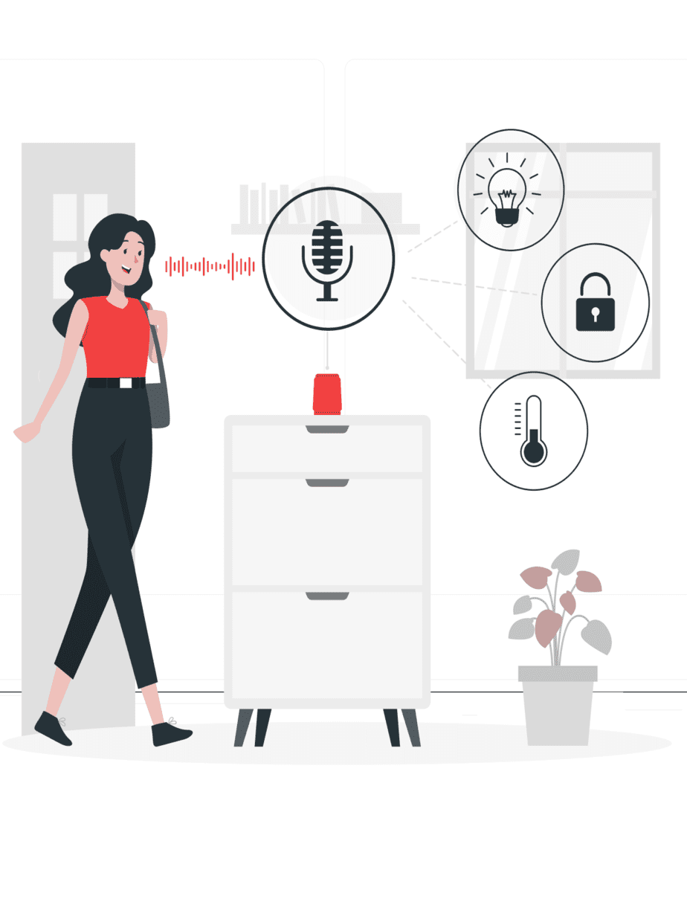
The Accelerating Shift towards VUIs: A Blend of Comfort and Convenience
One of the core reasons behind the growing popularity of VUIs lies in their ability to provide a seamless and intuitive user experience. The promise of hands-free, screen-less interactions with digital devices, where our voice commands execute tasks, is appealing to a wide swath of the population. We live in a fast-paced society where every second counts, and VUIs are instrumental in saving time by offering speedy and efficient assistance.

The statistics speak for themselves. A projection by Statista reveals a remarkable insight: the number of voice assistant devices is set to exceed 8.4 billion units by 2024. (Error: Reference source not found) To put that into perspective, this figure is higher than the world's current population. This astonishing projection underscores not just the popularity of VUIs, but also their future potential to become the dominant mode of interaction with technology.

The landscape of devices that incorporate VUIs is also expanding rapidly. As of May 2019, over 90,400 smart home devices had integrated support for voice assistants, with Amazon's Alexa alone accounting for more than 60,000 of these devices. (Error: Reference source not found) The versatility of VUIs is clear, with everything from smartphones to smart speakers to even refrigerators and lights being equipped with voice-command capabilities.
Today, VUIs are used for a multitude of tasks, ranging from searching the web and playing music to setting alarms and controlling smart homes. Their potential to simplify the complexities of our daily lives is undeniable.

The Emergence of a Voice-First Era: The Evolution of AI
At the heart of the revolution in VUI technology is the rapid advancement in Artificial Intelligence (AI), Machine Learning (ML), and Natural Language Processing (NLP). As these technologies continue to evolve, VUIs are becoming more accurate, contextual, and conversational.
VUIs are no longer just about processing commands but are moving towards an era of personalized and proactive assistance. Future VUIs will 'learn' from past interactions, predict user needs, and even offer unsolicited yet valuable advice. This will shift the paradigm from simple command-and-response interactions to multi-turn dialogues that simulate human conversations.

Privacy and Security: Overcoming Challenges for a Voice-Enabled Future
While the convenience of VUIs is a significant allure, potential concerns around privacy and security need to be acknowledged and addressed for their widespread acceptance. The design of future VUIs will need to ensure robust security measures, especially as they become increasingly integrated into our personal and professional lives. Overcoming this challenge will pave the way for VUIs to become even more deeply embedded in our day-to-day experiences.
VUIs and the Business World: A New Way to Work
Beyond personal use, VUIs hold immense potential for business applications. They can transform workplaces by automating routine tasks, facilitating meetings, and providing quick access to information. This increased efficiency and productivity, along with a more accessible digital environment, will be instrumental in driving VUI adoption in business settings.

From the Consumer to the Connected Ecosystem: A VUI-Driven Future
Looking ahead, we're moving towards a future where VUIs are not just in our phones or smart speakers, but an integral part of a connected ecosystem that spans across industries. Whether it's interacting with our car, ordering at a drive-thru, receiving medical advice, or teaching in a classroom, VUIs will serve as a digital companion, streamlining our interactions with the world around us.
In conclusion, the trend of Voice User Interfaces is not just about the technology; it's about a shift in how we interact with digital devices, how we work, and how we live. The blend of convenience, efficiency, and intelligence that VUIs offer positions them to be a core component of our digital future. As we journey forward, the voice revolution promises to be a transformative, enriching, and resonant part of our lives.

When discussing the Alexa platform, it's important to consider the perspectives of different participants involved. This can help us understand the platform from various angles and grasp its complete scope. Let's take a simplified look at the viewpoints of three primary participants: end-users, device manufacturers, and Skill developers.

End-users: These are the individuals who interact with Alexa through devices such as Echo speakers or other compatible devices. For end-users, Alexa serves as a virtual assistant, capable of providing information, performing tasks, and controlling smart devices. End-users appreciate the convenience and functionality offered by Alexa, as it enhances their daily lives with voice-activated capabilities.

Device manufacturers: These companies create and produce the hardware devices that incorporate Alexa technology. They integrate Alexa into their devices, enabling users to access the voice assistant's features and services. Device manufacturers recognize the value of incorporating Alexa into their products, as it enhances the overall user experience and expands the capabilities of their devices.

Skill developers: These individuals or organizations are responsible for creating third-party applications, known as Skills, that extend Alexa's functionality. Skill developers leverage Alexa's capabilities to build voice-driven applications that offer specialized services, ranging from playing games and providing news updates to controlling smart home devices. They benefit from the Alexa platform by reaching a wide user base and tapping into the voice-activated ecosystem (Figure 1).

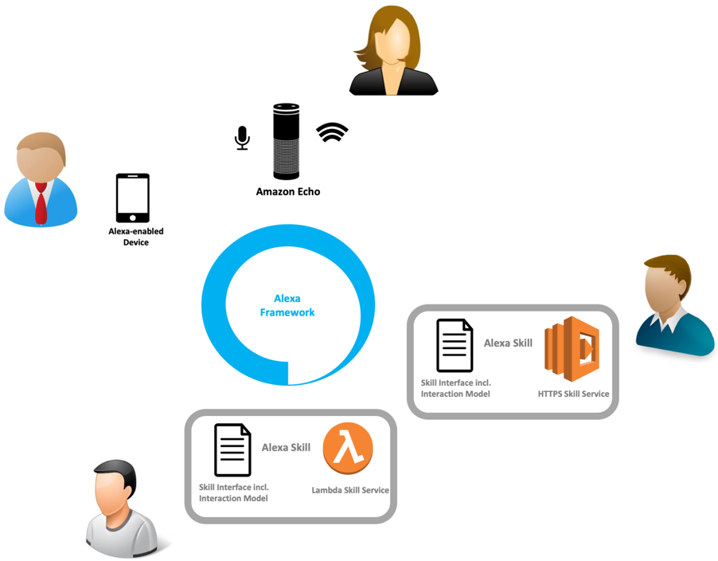
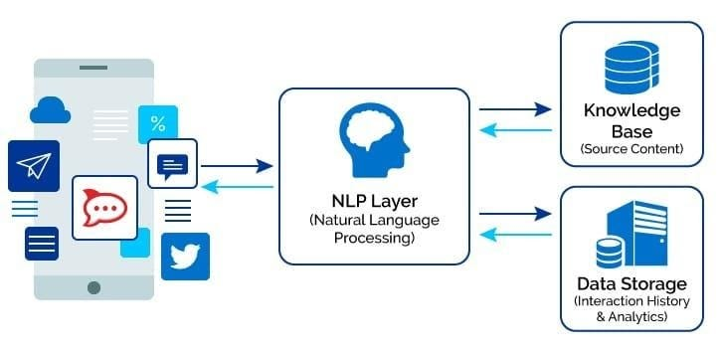
- Figure 1 High-level Alexa Architecture: Users and Skill Developers
- (Source: Biehl, M. (2019). Making Money with Alexa Skills: A Developer's Guide.)

Comparing the Voice Interface (VUI) with the Graphical Interface (GUI)

- GUI
A Graphical User Interface, or GUI (pronounced as either "gooey" or "G-U-I"), represents a type of user interface that allows users to interact with electronic devices through graphical elements such as icons and visual indicators. These elements are typically displayed on a screen and manipulated through a pointing device like a mouse or touch gestures.
Pioneered in the 1970s by the Xerox Palo Alto Research Center and later popularized by Apple and Microsoft, GUIs were a groundbreaking shift from the text-based, command-line interfaces that preceded them. By presenting users with visually intuitive elements - windows, icons, menus, and pointers (collectively known as WIMP) - GUIs revolutionized the way users interact with software applications and hardware devices.
In the present day, GUIs are virtually ubiquitous, being the primary mode of human-computer interaction in personal computers, tablets, smartphones, and other consumer electronics. They have been instrumental in making technology accessible to a wide range of users, irrespective of their technical proficiency, by transforming complex command sequences into simple, point-and-click operations.
A GUI's efficiency lies in its visual nature, which leverages human propensity for recognizing patterns and images. It supports easy learning and operation, even for novice users, promoting widespread adoption and usage of technology.

- VUI
As we venture deeper into the digital age, the way we interact with technology is constantly evolving. Among the many interfaces now part of our daily lives, the Voice User Interface (VUI) stands out for its intuitive and human-centered approach.
A Voice User Interface, or VUI, leverages advanced speech recognition technology to interpret and respond to vocal commands given by users. This innovation marks a shift from the manual, tactile interactions of the past, towards a more seamless, conversational (Figure2) mode of engagement with our devices.
The origins of VUI technology can be traced back to the late 20th century with the advent of Interactive Voice Response (IVR) systems. Primarily used in customer service, these rudimentary VUIs were programmed to recognize frequently asked questions and respond with pre-recorded messages, creating a one-way dialogue.
Fast forward to today, and we find ourselves in the midst of the 'second era' of VUI technology. Fueled by the convergence of speech recognition, natural language processing, and artificial intelligence, VUIs have transcended from simple voice-activated prompts to sophisticated personal assistants capable of understanding and executing complex verbal commands.
This transformation has led to diverse applications of VUIs, extending far beyond the confines of customer service. Whether it's ordering groceries with a simple voice command, asking for the latest news, controlling music playback, or receiving real-time weather and traffic updates, VUIs are integrating themselves more and more into our daily lives. From Apple's Siri and Amazon's Alexa to Microsoft's Cortana and Google's Assistant, these voice-activated technologies are redefining how we interact with the digital world.
As we look ahead, it's clear that VUIs will continue to play a pivotal role in shaping our digital interactions, breaking down barriers, and fostering a more intuitive and human-like engagement with technology. This introduction serves as an entry point into the fascinating world of Voice User Interfaces and their implications for our future.
Figure 2 Conversational user interface

UX Transformation: The Impact of AI in Shaping the Shift from GUI to VUI
Voice User Interfaces (VUIs) and Graphical User Interfaces (GUIs) both serve as critical mediums through which we interact with technology. They both seek to streamline and enhance the user experience, but do so in remarkably different ways that hinge on the unique strengths of voice-based and visual interactions.

A Voice User Interface (VUI) allows users to interact with a device using voice commands. Born out of earlier interactive voice response (IVR) systems, VUI has now entered its second era, leveraging artificial intelligence and natural language processing to provide a more intuitive and efficient interaction. VUI's range of applications extends from online shopping to fetching real-time weather updates, with popular examples such as Siri, Google Now, and Amazon Echo, manifesting its versatility.

On the other hand, a Graphical User Interface (GUI) facilitates user-device interaction through visually intuitive elements like icons, windows, and indicators. GUIs have come a long way from their inception at Xerox Palo Alto Research Center in the 1970s, to now being the primary interface mode in personal computers, tablets, and smartphones. GUIs have made technology accessible to the masses by transforming complex command sequences into simple point-and-click operations.

Despite these differences, VUI and GUI share common goals during the design process: understanding the user's needs, their use case, and the device they'll use. However, the interaction mechanisms vary significantly. In a VUI, a user asks for something specific, providing all necessary information at once, and shortening the navigation process. For example, a user may ask Google Home, "Okay, Google, what time is my flight?", and receive a precise response, which minimizes the learning curve as the user only needs to know the specific voice commands to perform their desired actions.

Conversely, a GUI requires several clicks or interactions to achieve a similar result. While GUIs are visually intuitive, their efficiency can be impacted by the necessity for multiple interactions, especially when compared to the single command nature of VUIs.

In terms of technological evolution, VUIs have made significant strides since artificial intelligence research began in the 1950s. A combination of efforts in building 'expert systems' and advancements in natural language processing has led to voice assistants that boast over 90% accuracy in speech recognition, as claimed by Google.

Interestingly, while GUIs are more established, there is a growing demand for 'conversation designers', professionals with expertise in UX design and dialog design for VUIs. This reflects the rising popularity and practicality of VUIs, especially in public transport, where hands-free interaction is highly beneficial, and in settings where speed is essential. After all, speaking a command is often faster than typing or navigating through a graphical interface.

While GUIs have made technology widely accessible and user-friendly through their visual intuitiveness, VUIs are fast becoming an attractive alternative, simplifying interactions through voice commands. This shift is driven by the evolution of artificial intelligence, the convenience and speed of voice-based interactions, and the 'invisible interface' it provides. As this technology continues to mature, it's conceivable that our future interactions with digital devices could become predominantly voice-based, transforming our digital experience.

Case study regarding the voice interface in accessing information in public transport
Considering my research on the use of VUI devices in public transport, we can discuss both types of interference in the specific context of these applications.

An example of GUI use in public transport would be navigation applications or bus/train ticketing applications that allowed users to view routes, timetables and seat availability. Users interact with these apps by tapping or swiping on the screen, navigating through different menus and sub-menus to get to the information they want. However, this process can be time-consuming and require visual attention, which is not always convenient while on the move.

On the other hand, an example of using VUI in public transport could be an application that allows users to ask for public transport information just by voice. For example, a user might say "Alexa, when is the next bus to downtown?" and receive an immediate response without having to look at a device screen. This can be extremely useful for the visually impaired or those who want to keep their hands free while moving.

Convenient, fast and easy to use, the VUI interface offers a new way of interacting with technological devices in the public transport environment. In my work, I discussed the advantages of VUI in this context, including that it enables hands-free interactions and is often faster than using a graphical interface. You can also focus on how VUI technology can be adapted and created to better meet the specific needs of public transport users.

Chapter 4: Internet of Things (IoT) and Its Applicability in Public Transport

Exploring IoT Technology
The Internet of Things (IoT) is an emerging technology that interconnects various devices and sensors, thus creating a network of objects capable of collecting and exchanging data via the Internet. The concept of IoT is based on the idea of embedding sensors and smart capabilities in ordinary objects, thus creating an interconnected and digitized environment that improves user experience.
IoT devices can range from simple sensors that collect information about the environment to complex control and analysis systems. They can include everyday objects such as refrigerators, thermostats or smart light bulbs, but also advanced devices such as autonomous vehicles or complex industrial production monitoring and control systems. ()
A concrete example of an IoT device is the Amazon Echo, a smart speaker that uses the Alexa virtual assistant to respond to voice commands. Through this device, users can control various elements of the smart home, request information or use various services through simple voice commands. This is a great example of how IoT technology can improve people's daily lives by creating an interconnected and intelligent environment. ()
IoT technology is based on several essential components. Sensors are the core component, responsible for collecting data from the source. These can include temperature, humidity, pressure, position sensors, GPS sensors and more. This data is then transmitted over an internet network to data processing platforms, where it is analyzed and used to generate valuable information or to control other devices or systems.
When we talk about IoT in the context of the Amazon platform, we mean a series of services and technologies that enable the development, implementation and management of IoT solutions. One of these services is Amazon IoT Core, an IoT device management platform that enables secure device connection and management, data collection, storage and processing, and integration with other Amazon services and applications.

Another important component of the Amazon IoT ecosystem is Alexa, the virtual assistant that enables voice interaction with smart devices. Through Alexa, users can control IoT devices through voice commands, creating a simple and intuitive user experience. Alexa also allows the development of "skills" or applications that extend the functionality of the virtual assistant, thereby enabling closer integration with IoT devices and other services and applications.

In addition, Alexa allows the development of "skills" or applications that extend the functionality of the virtual assistant. These skills can be developed to allow Alexa to be integrated with various services or applications, thereby allowing users to control these services or applications through voice commands. This is another way that IoT technology can be used to improve the user experience and create a smart and interconnected living environment.
So, IoT in the context of the Amazon platform is a combination of technologies, services and devices that work together to create a digitized and interconnected environment. Through this network, ordinary objects can be transformed into intelligent devices capable of collecting and processing data, communicating with each other and with users, and responding to commands and changes in the environment.

Advantages and Challenges of Using IoT in Public Transport

The use of IoT in public transport offers numerous opportunities to improve efficiency and passenger service. However, like any emerging technology, IoT brings with it its own challenges and obstacles that require attention and strategic thinking.

Let's start with the benefits. First, IoT enables real-time monitoring of public transport vehicles. By using GPS sensors connected to the Internet, the exact position of each vehicle can be known at any time. This gives users the ability to receive real-time information about when the next vehicle will arrive, which improves the passenger experience. The management of the transport network can also be improved, with the ability to monitor the efficiency and performance of each route.

Another advantage of IoT in public transport is the possibility to collect an enormous amount of data. IoT sensors can collect data on the number of passengers, duration of trips, traffic conditions, vehicle condition and more. This data, once analyzed, can provide valuable information that can be used to improve route planning, optimize vehicle frequency and generally improve passenger service.

In addition, IoT can play a significant role in improving accessibility and inclusion in public transport. Through IoT devices, people with visual or hearing disabilities could receive information about public transportation directly through their connected devices. For example, an Alexa device could announce when the next bus will arrive, making access to public transportation easier for these people.
More and more people own voice-controlled devices such as Google Home, Amazon Alexa, etc., which opens up new opportunities for integrating IoT into users' daily lives. In the context of public transport, these devices can provide real-time information about the schedule of means of transport, thus improving the user experience.

However, to ensure that this technology is accessible to all, a continuous effort is needed to develop the necessary infrastructure. Not only do internet networks need to be reliable and fast, but IoT devices and data analytics platforms need to be robust enough to handle the growing demand.

Despite these benefits, implementing IoT in public transportation also comes with its own challenges. One of the biggest hurdles is data security and privacy. Data collected by IoT sensors can include sensitive information about user behavior and travel patterns, which raises privacy concerns. At the same time, IoT devices can be vulnerable to cyber-attacks, which can put the security of data and transport systems at risk.

The cost of implementing IoT technology can also be a challenge. It includes the cost of the IoT devices themselves, the cost of developing and maintaining the necessary technological infrastructure, and also the cost of training staff and educating users.

Additionally, a robust technology infrastructure is required to support large-scale IoT deployment. This can include reliable communications networks, data storage and analytics platforms, and IoT device management capabilities.

The Rise of Voice Assistants and their Increasing Popularity

The rapid development of technology and Artificial Intelligence (AI) has led to the emergence of voice assistants like Amazon's Alexa, Google Assistant, and Apple's Siri. These virtual helpers, powered by AI and Natural Language Processing (NLP), are changing the way we interact with our devices by allowing us to command and control them through spoken language. This evolution is largely due to the advancements in speech recognition technology, which has now reached a level of accuracy comparable to human listening.

In the context of the Internet of Things (IoT), voice assistants have become a fundamental element. They act as the interface between the user and their connected devices, making it possible to control and coordinate a broad range of IoT devices with only voice commands. The increasing popularity of these voice assistants is attributed to their convenience, simplicity, and increasing capabilities.

In terms of convenience, voice assistants eliminate the need for physical interaction with devices, making them especially useful when our hands are occupied or when the device is out of reach. They can perform tasks like playing music, setting alarms, and even ordering groceries, all while we carry on with our other activities.

Their simplicity is another factor contributing to their popularity. Interacting with a voice assistant feels natural and intuitive because it uses a form of communication that we have been practicing since childhood - speech. There's no need to learn complex commands or navigate through multiple menus, all one has to do is ask.

The increasing capabilities of voice assistants also play a big role in their rising popularity. They are constantly learning and evolving, with updates being rolled out frequently that expand their knowledge base and skills. They can now do things like control smart homes, provide real-time traffic updates, and even give health advice, among many other things. ()

By 2024, the global voice recognition technology market is expected to reach $26.8 billion, and the number of voice-activated digital assistants will reach 8 billion. This trend has also prompted companies to adjust their sites for voice queries and marketers to adapt their strategies to match new consumer behaviors.

In addition, more than half of the population currently uses voice search in their daily lives to get answers to various questions. Surely, you too have turned to voice search at some point to look for products or to find solutions to various dilemmas. ()

- According to the data, there are 4.2 billion voice assistants in use in 2023, a figure expected to reach 8.4 billion in 2024.

- Voice assistants respond to an average of 93.7% of search queries.

- There are over 1 billion voice searches conducted each month.

- More than 50% of adults have reported using voice search daily.

- In 2023, 27% of people use voice search on mobile devices.

- Over 40% of voice search results come from featured snippets.

- An average voice search result in the SERP (Search Engine Results Page) takes 4.6 seconds to load.

- More than 20% of searches on the Google app are made using voice search.

- Approximately 58% of consumers use voice search to find local businesses.

- 41% of adults in the US use voice search daily.

- Google Assistant supports over 30,000 smart home devices.

- 45.1% of voice assistants reported preferring Siri, Apple's voice assistant, for voice search.

- Voice search purchases are estimated to exceed $40 billion.

- General statistics about voice search:

- 27% of people use voice search on mobile devices.

- The average voice search result contains 29 words.

- 36.6% of US residents use voice assistants.

- 123.5 million people used voice assistants in 2022, compared to 132 million users in 2021.

Statistics is taken from (Error: Reference source not found)

Year | Number Of Voice Assistant Users.
2017 | 79.9 million
2018 | 03.9 million
2019 | 115.2 million
2020 | 128 million
2021 | 132 million
2022 | 123.5 million
2023 | 125.2 million
Table 1 Table 1 Number of voice assistan users

This table shows the percentage of people using different digital assistants:

- Google Assistant and Apple's Siri are the most used, each preferred by 36% of users. This means that about a third of all users use each of these digital assistants.
- Microsoft Cortana is used by 19% of people, which is about a fifth of all users.
- Amazon Alexa is used by 25% of users, which is a quarter of all users.
- Only 1% of users use other digital assistants not on this list.

Digital Assistants | Percentage Of People
Google Assistant | 36%
Apple’s Siri | 36%
Amazon Alexa | 25%
Microsoft Cortana | 19%
Other | 1%
Table 2 Percentage of people using different digital assistants

Research shows that people use voice search most often when they are alone at home, with a percentage of 60%. This can be explained by the fact that at these times, users can benefit from peace and comfort, thus making the interaction with the voice assistant easier and more efficient. This is a crucial aspect when it comes to using technology to manage public transport, because before leaving home, users can easily check bus or train timetables through the voice assistant. (Error: Reference source not found)

Even when at home with friends, over 50% of people use voice search. Thus, even in a social environment, users can benefit from the facilities offered by voice assistants to plan journeys with public transport.

In the professional context, about 50% of people use voice search when they are alone in the office. This can be extremely useful for organizing public transport trips, either to get to a business meeting or to plan your way back home.

Moreover, even when they are in a restaurant with friends, more than 40% of users turn to voice search. This proves that voice assistants can be used successfully even in noisy environments, allowing users to get information about public transport in any context.

When in the office with colleagues or at the gym, over 30% of people use voice search. This demonstrates the flexibility and versatility of voice assistants, which can provide information about public transport in a wide range of scenarios.

Similarly, more than 30% of users use voice search when they are alone in a restaurant, attending a party or traveling on public transport. This is another indicator of the versatility of voice assistants, which can be used to navigate the complex public transport system regardless of location or context.

Finally, even in less common places like public restrooms or movie theaters, more than 20% of users use voice search. This underlines the ability of voice assistants to provide valuable information about public transport anytime, anywhere.

Environment | Percentage Of Users
Home alone | 60%
Home with friends | Over 50%
Office alone. | Approximately 50%
Restaurants with friends | Over 40%
Office with Coworkers | Over 30%
Gym | Over 30%
Party | Over 30%
Restaurant alone. | Over 30%
Public transportation | 30%
Restaurants with acquaintances. | Over 20%
Public restroom | Over 20%
Theater | Over 20%

In general, voice assistants exhibit a high level of accuracy, being capable of correctly responding to 93.7% of all search inquiries on average. This demonstrates their proficiency and reliability in providing accurate information, a critical attribute particularly when dealing with queries about public transportation schedules, routes, or delays.

When specifically considering Google Assistant, its performance across all devices shows an average answer match of 22%. This metric implies that for about one-fifth of queries, Google Assistant provides an exact match to the answer the user is seeking. Despite this seeming low, it's important to bear in mind that this reflects an average across all types of queries, many of which might be more complex or nuanced. For more straightforward queries, such as those typically associated with public transportation, the match rate could be significantly higher.

The challenges of voice search

41% of people said they fear their digital assistants are actively listening or recording them. This is a significant obstacle to the universal acceptance of voice assistants because it involves privacy and security concerns. In the context of public transportation, this is an important consideration because sensitive user information, such as current location or travel routine, could be exposed.

Over 40% of people are concerned about their privacy when they have digital assistants in their devices. This is another major challenge to the acceptance of voice search, especially if people fear that their private information can be accessed or misused. Again, in the case of public transport, this is a relevant concern, as users frequently talk about their travel plans in front of their voice assistants.

64% of people said they accidentally used a voice assistant in the past month. This can lead to nuisance, privacy violations, or unintended consumption of data or battery resources.

Voice search trends and forecasts

Voice search technology is readily adopted by 18-24 year olds. This indicates a significant growth opportunity among young people, who tend to be more open to adopting new technologies.

By the end of 2024, smart speaker sales are expected to exceed $30 billion. (Error: Reference source not found) This highlights the continued growth in popularity of voice search devices and suggests that they will become more and more integrated into our daily lives.

In the future, voice assistants are expected to be able to understand the user's mood and respond accordingly. This represents an exciting new frontier in voice search technology and suggests that our interactions with voice assistants could become increasingly personalized and context-sensitive over time.

Future Directions in Researching the Use of IoT in Public Transport

The continuous technological advance and the rapid growth of the Internet of Things (IoT) open new perspectives for the improvement and modernization of public transport. Future research in this area can take many directions, all with the potential to change the way we move around and interact with transportation systems. From streamlining vehicle monitoring to improving accessibility, IoT has the potential to bring numerous benefits to public transportation.

One of the areas where IoT can have a significant impact is the monitoring of public transport vehicles. Future research could explore ways to use IoT sensors to more efficiently and effectively monitor vehicle performance, from fuel levels and parts wear to driver behavior. This could help optimize costs, prevent problems before they occur and improve passenger safety.

Additionally, with an increasing amount of data collected through IoT devices, future research could investigate ways to use this data to improve public transportation. Thus, machine learning algorithms can be developed to analyze this data and identify trends, such as those related to traffic or passenger behavior. This information could then be used to optimize route planning and scheduling, resulting in more efficient and convenient public transport for passengers.

Chapter 5: Analysis of the Amazon Alexa Ecosystem
Alexa represents much more than just an application offered by Amazon; it is, in fact, a vibrant ecosystem comprising a wide array of unique voice apps, all housed under the umbrella of the Alexa platform. Each participant within this ecosystem – software providers, hardware providers, and Amazon as the platform provider – has a distinct, essential role to play.

Software providers are able to concentrate on crafting innovative Skills, adding value to the user's interaction with Alexa. Freed from the constraints of hardware development and the complexities of voice recognition and natural language processing technologies, they can focus solely on delivering fresh and innovative user experiences. ()

Meanwhile, hardware providers are tasked with creating Alexa-compatible devices, ensuring seamless functionality with the platform. Their focus lies in the realm of hardware, without the necessity to venture into the creation of novel software applications or delve into the intricacies of voice recognition and language comprehension models.

Amazon's role goes far beyond just providing the essential technical infrastructure, voice recognition, and natural language understanding technologies. Amazon effectively unites all stakeholders – both providers and customers – streamlining their interactions, establishing foundational guidelines, and skillfully orchestrating their efforts to offer an attractive, feature-rich experience to the end-user.

Chapter 6: Presentation of the Developed Application

Vision and Objectives of the Application
The vision of this app is to redefine the way travelers interact with public transportation, transforming a routine, often difficult task into an accessible and easy-to-navigate experience. By using voice user interface (VUI) technology, the app aims to remove obstacles encountered in interacting with traditional graphical user interface (GUI)-based systems, such as the need to navigate through complex menus or read small text on mobile device screens .

The first goal of the application is to develop an ASP.NET API that can effectively communicate with an Alexa skill. With this, the application will be able to respond promptly to voice commands, providing relevant information about bus schedules, routes or even delays. Voice interaction gives users the ability to focus on other activities while getting the information they need, representing a major advantage over using traditional GUI-based applications.

Another objective is to simplify the process of using the transport system as much as possible. By using the voice interface, users will be able to request specific information, thus eliminating time spent navigating through multiple options and menus. The app also aims to provide clear and concise information, thereby reducing confusion or ambiguity.

Finally, another major goal is to provide the ability to customize the user experience. That could include saving your favorite buses or routes, which can be quickly accessed via voice commands. This feature will allow users to save time and customize their experience based on their specific needs.

Essentially, the vision and goals of this app focus on improving the accessibility and efficiency of using public transportation through the use of VUI technology. By achieving these goals, the app has the potential to fundamentally change the way we travel, making public transportation a more attractive and convenient option for all.

System Architecture

The architecture of our application consists of a multi-layered .Net API, deployed on AWS as a serverless lambda function within a Virtual Private Cloud (VPC), and an Alexa skill also realized as a lambda function. This modern cloud-native design promotes scalability, agility, and reliability, forming a robust framework for our application's operation.

Starting with the .Net API, it comprises of three distinct layers:
The three-layer architecture is a software design pattern that divides an application into three interconnected layers which for me were structured in 3 projects
(Figure 3) :

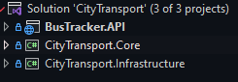
- Figure 3 Backend Arhitecture Project Structure

- Domain Layer (also known as the Core) (Figure 4): This is where the business logic lives. In Domain-Driven Design (DDD), as presented by Eric Evans (), this layer contains Entities, Value Objects, Aggregates, Services, Repositories, and Domain Events, among other things. These components capture the rich semantics of the problem domain, and the interactions between them encapsulate key business processes and rules.

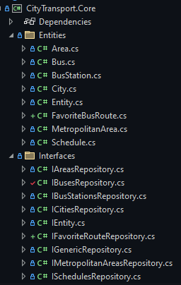
Figure 4 Domain Layer folder structure

- Infrastructure Layer (Figure 5): This layer provides concrete implementations of the interfaces defined in the domain layer, usually using technologies specific to the application's environment. For instance, this might include database access code (such as repositories implemented using Entity Framework in a .NET application), file system operations, network communication, and other "plumbing" code that doesn't directly relate to the problem domain, but is necessary for the application to function.

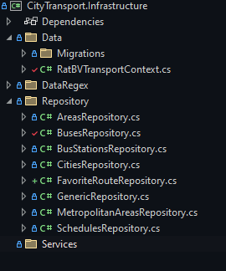
- Figure 5 Data Acces Layer folder structure

This serves as the data access layer, using the repository pattern to offer a neat, abstracted way to manipulate our data entities. Entity Framework is used as the primary Object-Relational Mapping (ORM) tool, enabling a simplified, code-first approach to data access and manipulation. This layer is also responsible for maintaining our database migrations, ensuring consistency and traceability of changes.

- Application Layer (also known as the Interface or API Layer) (Figure 6): This layer acts as a bridge between the user and the domain layer. It's responsible for tasks like handling user input (such as HTTP requests in a web application), calling the appropriate domain services, and returning responses. The responses could be views in an MVC application, JSON data in a REST API, or spoken phrases in a voice-controlled application like an Alexa skill.
ASP.Net API is the interface layer, constructed on the Model-View-Controller (MVC) architecture, allowing for a clean separation of concerns. The data transfer objects (DTOs) used in this layer provide a means for data serialization, enabling efficient communication between the server and the client.
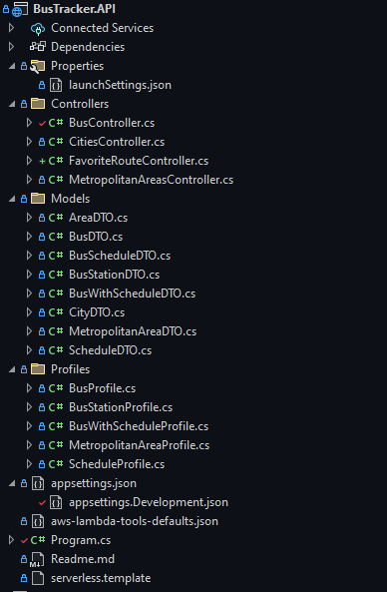
- Figure 6 Aplication Layer folder structure

In a well-structured application following this pattern, each layer has a clear and distinct role, and dependencies between layers are carefully controlled. This leads to a codebase that's easier to understand, maintain, and modify, which is why the three-layer architecture is a common choice for complex business applications.

On the client-side, we have our Alexa skill, written in Node.js, and modularized using intent handlers for increased maintainability and scalability.  The intent handlers (Figure 7) are designed to manage specific user interactions, processing user utterances and returning appropriate responses. | 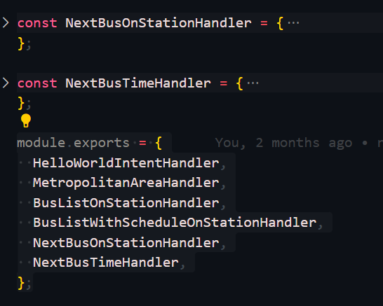  - Figure 7 Handlers on client side

Our application is set to communicate with Alexa via an API gateway (Figure 9), acting as a secure conduit between the serverless back-end and the client-side Alexa skill.
The database for our application is an SQL Server instance, hosted on Amazon's Relational Database Service (RDS). This fully managed service provides a cost-efficient and resizable capacity while automating time-consuming administration tasks, freeing us to focus on our application and business logic.

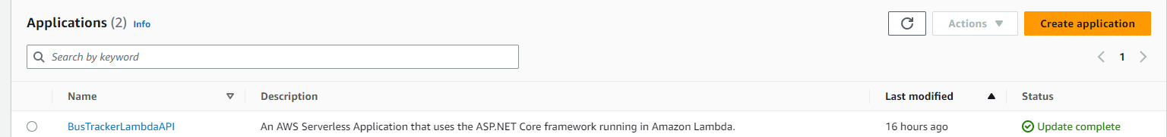
Figure 8 Lambda Function on AWS Platform

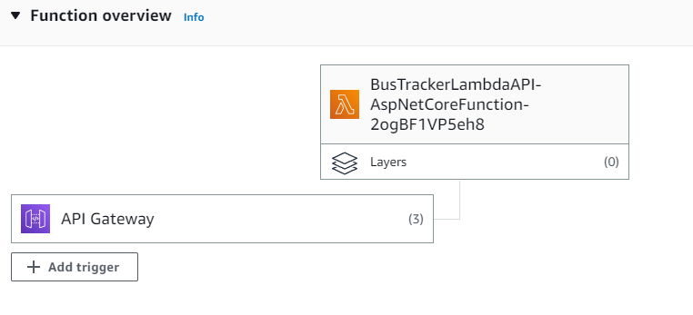
Figure 9 Backend Lambda communicating with the API to a bridge

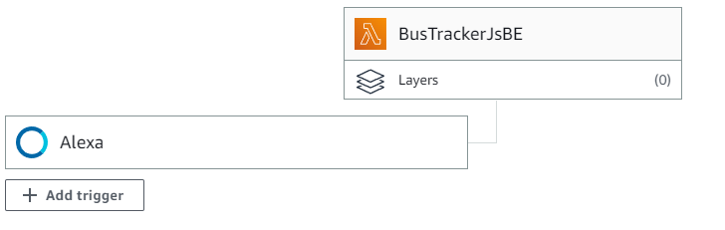
- Figure 10 Client Lambda communicating with Alexa service

Overall, our architecture illustrates a modern, cloud-based solution, leveraging key AWS services and serverless technologies for optimum performance and user experience. An accompanying diagram (Figure 10) visually represents the entire flow and structure of our application.

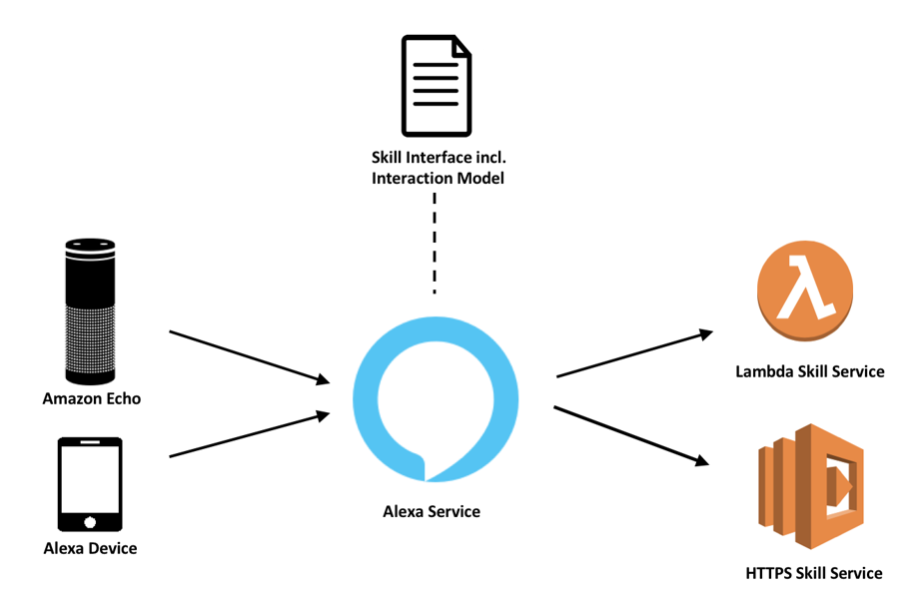
- Figure 11 Alexa Microservices Architecture

User Interface (UI) and User Experience (UX)
The User Interface (UI) for an Alexa Skill is primarily voice-based, and hence the focus is on crafting a smooth, intuitive, and engaging conversation experience.

Universal Design Accessibility: A design that serves the needs of a broad spectrum of users holds immense value from a business perspective. Utilizing voice user interfaces (VUIs) and speech recognition can greatly enhance accessibility, particularly for individuals with specific disabilities such as visual impairments or repetitive strain injuries. This capability is also beneficial for all users in certain situations, like when hands-free operation is required.

Enhanced, 'Human-Like' Interactions: The nature of voice-based conversations infuses the user experience with a more 'human' touch. This sense of interpersonal interaction can be further amplified by employing empathic and conversational language in the VUI, lending personality to the interaction. Additionally, the quality of the interaction can be enriched by incorporating different voice tones. This not only makes the information conveyed richer but also strengthens the perception of a human-like conversation

Since the user interacts with Alexa through voice, the voice user interface is critical. The VUI is defined by your interaction model (intents, slots, etc.) and the dialog management you set up.

In this skill, the VUI will include intents like "NextTimeIntent," "AddFavoriteRouteIntent," "GetFavoriteRouteIntent," etc. Each of these will have slots to capture key details, like bus line, stations, and the favorite route name.

The dialogue should feel natural and effortless to the user. This is accomplished by using clear and conversational language, confirming user requests when necessary, and providing useful and appropriate prompts.

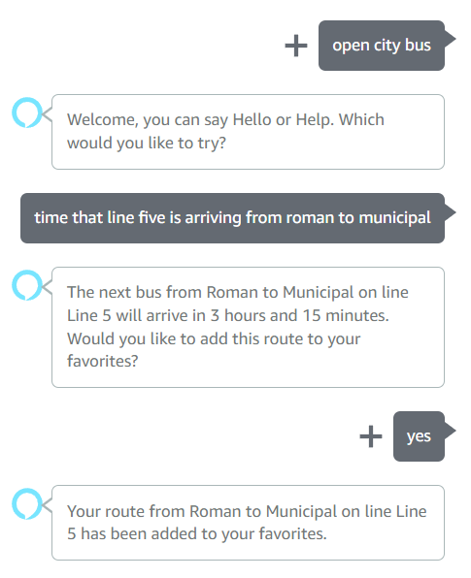
- Figure 12 Natural model language.

For example, after a successful retrieval of the next bus time, Alexa might say, "The next bus from [Station From] to [Station To] on line [Line] will arrive in [Time Remaining]. Would you like to add this route to your favorites?" (Figure 10)

The UX of this skill would be focused on minimizing the number of steps the user has to take to accomplish their goal and providing clear and concise feedback.

For example, the user should be able to retrieve the next bus time or add a favorite route with as few interactions as possible. The skill should also handle errors gracefully - if a bus line or station name is not recognized, the skill should prompt the user to repeat or rephrase their request, rather than simply failing.

Moreover, the skill should be designed to remember the user's favorite routes across sessions. This would require linking the skill to a user profile and using a persistent database (like DynamoDB) to store favorite routes.

Remember, UX is not just about how the skill behaves, but also about how it makes the user feel. The goal is to make the interaction feel efficient, easy, and enjoyable.

Until recently, the design of user interfaces for applications was predominantly focused on graphical user interfaces. This was understandable, as most applications were either mobile or web apps primarily utilizing visual elements for interaction. However, we are now witnessing the emergence of a new pillar of usability: voice interface design, which stands parallel to graphical user interface design.

Voice interfaces are not poised to replace graphical user interfaces, but rather they are designed to enhance them. A crucial factor in this evolution is the integration of the voice interface with the graphical one. (Error: Reference source not found)

Chapter 7: Technologies Used in Application Development

Using ASP.Net

.NET (pronounced dot net) is a framework developed by Microsoft that runs primarily on Microsoft Windows. It is a platform that enables developers to build and run software applications for Windows, Windows Server, Microsoft Azure, mobile and web.

.NET includes a broad class library called the Framework Class Library (FCL) and provides language interoperability across multiple programming languages. In other words, code written in one language can be used in another. It supports a variety of languages such as C#, VB.NET, F# and others.

This platform provides a controlled programming environment where software can be developed, installed, and executed on Windows-based operating systems. The .NET Framework contains tools, libraries, and APIs that help developers create applications, making the process more efficient and streamlined.

By 2021, .NET has evolved into a unified platform called .NET Core, which is a cross-platform (runs on Windows, Linux, and macOS) and open-source framework for building modern applications. It is used to build cloud based applications, IoT applications and is also used in Machine Learning.

C#
C# (pronounced "C Sharp") is a multi-paradigm programming language developed by Microsoft as part of the .NET platform. It is designed to be simple, modern, statically typed, and object-oriented, inheriting many features from Java and C++, but also adding other unique elements that make it easy to learn and use.

C# is known for its impressive performance, thanks to the deep optimization that has taken place over the years and the just-in-time (JIT) compiler used by .NET. This means that the code is compiled to native machine code immediately before it is executed, which can lead to significant performance improvements. Over the years, it has evolved to include features that enable asynchronous programming, which improves application performance in I/O scenarios and other resource-intensive situations.

Another important aspect of C# is the Garbage Collector (GC). The Garbage Collector in C# automatically handles allocating and freeing memory, taking the burden off the programmers. It keeps track of objects that are currently in use by the application, cleans up those that are no longer needed, and reclaims memory. While this process may cause a small delay in application performance, the benefit is that it significantly reduces the risk of memory errors such as memory leaks.

These features make C# a powerful and flexible programming language, perfect for a wide range of applications, including enterprise applications, web services, mobile applications, and games.

The C# language natively supports multiple programming paradigms, including procedural, object-oriented, and functional programming. This makes C# an extremely flexible tool in software development, allowing developers to choose the most appropriate method to solve various problems.

Furthermore, C# provides advanced exception handling features, providing a robust framework for error handling and reporting. This is critical to ensuring the reliability and stability of applications in production.

In terms of performance, the C# language was designed to work closely with the .NET Common Language Runtime (CLR), a key component that manages the execution of .NET code. It provides efficient memory management, Just-In-Time compilation and other services that help optimize application performance.

The fact that C# is tightly integrated with the Visual Studio development environment is another reason why it was an excellent choice for application development. Visual Studio provides an extensive set of tools for writing, testing, and debugging C# code, making it easy to create efficient, high-quality software.

In the end, the choice of C# for application development was based not only on its impressive technical features, but also on personal familiarity with it. This familiarity allowed for faster and more efficient development, avoiding the learning curve associated with adopting a new language.

The Future of .NET Framework in 2023: Trends and Insights

Demand for .NET will continue to grow as new and more efficient technologies are developed. For example, C# has been around for over a decade, but remains one of the most popular programming languages on the market even today. Its popularity is due to its ease of use and ability to collaborate with other languages, such as Java and JavaScript.

In its own context, I would point out that this constant preference for C# is largely due to its ease of learning and versatility in tackling various programming problems. Moreover, its native compatibility with other important languages such as Java and JavaScript gives it a considerable advantage in today's software development ecosystem.

The continued success of the .Net framework is due to the way it combines efficiency with functionality. This framework has been designed to be compatible with a number of versions of Microsoft operating systems, from Windows Vista and XP to Windows 7 and Windows Server. () Plus, newer versions stay in line with the latest technologies, offering support for cloud computing, mobile devices, and web services—essential features in today's digitalized environment.

Serverless Computing Using .NET Core

In a world where serverless computing is gradually gaining supremacy as the leading technology in cloud computing, Microsoft's .NET Core is emerging as a reliable tool for developing this type of applications.
Alexa Skill, one of the concrete examples of using serverless computing, benefits directly from the advantages offered by .NET Core. This, being an open-source, cross-platform framework, allows the efficient development of cloud-native applications, including the Alexa Skill. The latter, based on Lambda functions, represent an ideal use of serverless paradigms, which are known for cost efficiency, scalability, security and stability.

Serverless computing is often chosen for its ability to allow companies to scale their application operations without worrying about managing server infrastructure. Because costs are directly tied to usage, organizations only pay for what they actually use, without wasting resources with idle or underutilized servers.

By taking a serverless approach to Alexa Skill development, organizations can benefit from elastic scalability that allows the application to efficiently respond to variations in demand. Additionally, the fact that .NET Core provides native support for serverless application development makes it a powerful ally in the modern digital age.

The continued development of .NET Core, along with strong support from Microsoft and an active developer community, suggests that .NET Core will play an increasingly important role in the evolution of serverless computing and its growing popularity.

In my opinion, a significant increase in demand for .Net developers is expected as more and more companies start using this technology in their business processes and products. Over the years, we have seen a steady increase in the use of .Net, becoming a predominant programming language among programmers and software developers.

7.1.1 Version
For my project, I chose .NET 6 as the technology base because of a series of powerful features that make it ideal for developing my application.

One of the most notable features of .NET 6 that attracted me is the Minimal API. In the case of my app, Minimal API gives me the ability to create a clean and efficient API that communicates with my Alexa skill and database without the need for heavy additional code.

Another major factor that led me to choose .NET 6 was the fact that it has Long Term Support (LTS). Microsoft provides three years of support for each LTS release (Figure 5), which means my app will benefit from security and performance updates throughout that term. This is an important consideration for the long-term sustainability and stability of the project.

.NET 6.0, released in November 2021, is part of the .NET Unified Platform series of releases aimed at simplifying and modernizing the .NET ecosystem. This release brings significant improvements in performance, productivity and security and introduces a number of new and useful features for developers.

One of the most notable new features introduced in .NET 6 is the Minimal API. This concept is a simplified approach to building web APIs in ASP.NET Core with a focus on minimalism and developer productivity.

Minimal API encourages a "just enough" approach to defining APIs, allowing you to create a functional web API with much less code and less ceremony compared to traditional MVC or Razor Pages approaches.

For example, instead of having to define an entire controller with separate actions for each endpoint, with Minimal API you can define an endpoint directly in Startup.cs or Program.cs, with a simplified syntax that focuses strictly on handling requests and responses HTTP (Figure 3).

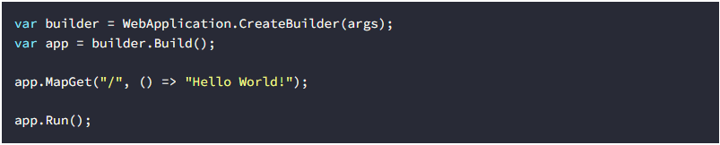
- Figure 13 Minimal API simplified syntax

In addition, Minimal API encourages a more functional approach to building APIs, with an emphasis on independent functions that handle requests and responses, instead of class-based controller methods.

This can make the application easier to understand and maintain, especially for smaller projects or developers who prefer the functional coding style. It can also help improve performance because there is less bootstrapping code and less overhead in processing requests.

Minimal API is a significant step forward for the .NET ecosystem, providing developers with a more direct and efficient way to build fast and efficient web APIs.

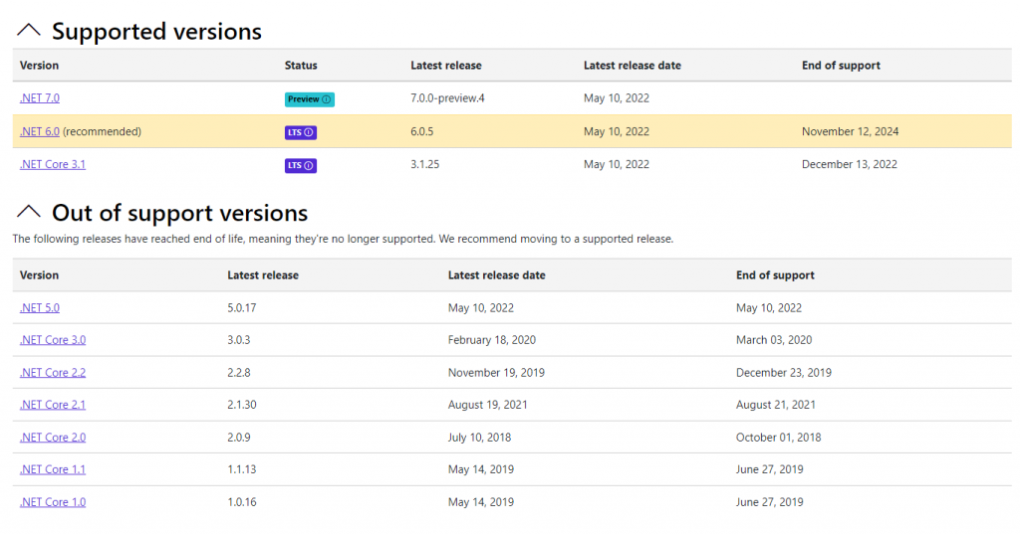
Figure 14 Supported versions

Microsoft ensures that its users don't face any inconveniences, as they have plans to release the highly anticipated 7.0 version of .NET in November 2022.( Figure 4) Additionally, users can look forward to the upcoming release of .NET 8.0 in 2023.()

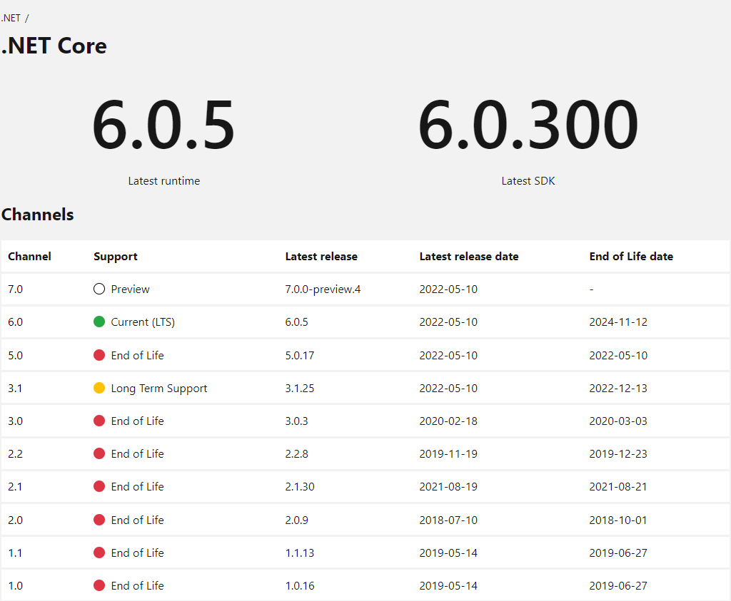
- Figure 15 NET 6.0 LTS release, which will only get support for three years

7.1.2 Libraries

As a library I have used Entity Framework (EF) which
is a popular Object-Relational Mapping (ORM) framework developed by Microsoft. It is a tool that allows developers to work with relational data as strongly-typed objects, providing a layer of abstraction over the underlying database interactions. The aim of Entity Framework is to reduce the amount of repetitive code that developers need to write when performing database operations.

Here are some key features of Entity Framework:
- Database-Agnostic: EF can work with a variety of databases, which makes your application more flexible. By using EF, you can switch the underlying database without changing much of the application code.
- LINQ Support: EF supports Language Integrated Query (LINQ), allowing developers to write queries in .NET languages like C#. This means you can write queries using strong typed objects, which can help to prevent errors that could arise from using string-based SQL queries.
- Database Schema Creation: EF can generate database schema based on your .NET classes. This is great for rapid prototyping, and it can save time when setting up a new project or when making changes to your data model.

Entity Framework supports two main approaches to designing the schema of your database: Code First and Database First. Each approach has its own benefits and use cases.
Code First: In the Code First approach, you first define your model classes (the "code") in your .NET application. You can also define the relationships between the classes using data annotations or the Fluent API, which are both features of Entity Framework. Once your model classes are defined, Entity Framework can then automatically generate (or update) the database schema to match your model. This is done using migrations, which are a feature of Entity Framework that allow you to keep your database in sync with your code.

The main advantage of the Code First approach is that it allows you to work in a "domain-driven" way, where your code defines the database, not the other way around. This can be more natural for developers and can result in a cleaner, more intuitive design. It also allows for rapid prototyping, as you can quickly change your model classes and have those changes automatically reflected in the database.

Database First: In the Database First approach, you start with an existing database, and Entity Framework generates the corresponding model classes for you based on the schema of that database. This can be useful if you are working with a legacy database, or if your database schema is designed by a Database Administrator (DBA) who prefers to work directly with SQL.
- Change Tracking: EF can automatically track changes made to your objects and translate them into the appropriate SQL commands.
- Lazy Loading: EF supports lazy loading, which means related data is only loaded from the database when it's actually needed. This can help improve application performance by reducing unnecessary data fetching.

Using Node.js
When embarking on the development of my Alexa skill, the decision to utilize Node.js was driven by a range of considerations, fundamentally revolving around the language's efficiency, ease-of-use, and compatibility with AWS Lambda, which is the hosting platform for Alexa skills.
Node.js, a JavaScript runtime built on Chrome's V8 JavaScript engine, allows developers to write server-side scripts in JavaScript. Historically, JavaScript was used predominantly for client-side scripting, where scripts written in JavaScript are embedded in a webpage's HTML and run client-side by a JavaScript engine in the user's web browser. Node.js revolutionized this by enabling JavaScript to be used for server-side scripting as well, thus allowing the production of dynamic web page content before the page is sent to the user's web browser. ()
Introduced in 2009 by Ryan Dahl, Node.js rapidly grew in popularity due to its non-blocking, event-driven architecture, which makes it lightweight and efficient. This event-driven architecture is ideal for real-time applications that run across distributed devices, making it perfect for an application like an Alexa skill, where rapid, real-time responses are crucial.
The popularity of Node.js can be attributed to its speed, scalability, and efficiency, as well as the fact that it uses JavaScript, one of the most widespread programming languages known to a vast majority of web developers. Moreover, Node.js has a robust ecosystem, supported by npm, the package manager for JavaScript, providing developers access to countless modules and packages to speed up development.
In the case of Alexa skills, Node.js is one of the languages officially supported by AWS Lambda, which is the underlying platform for Alexa skills. Using Node.js allows developers to write the logic of their Alexa skill in JavaScript and easily deploy it to AWS Lambda. Furthermore, Amazon provides an Alexa Skills Kit SDK for Node.js, which simplifies the process of skill development by handling many of the more complex tasks involved.
In summary, the decision to utilize Node.js for the development of my Alexa skill was influenced by its ability to handle real-time interaction, its efficiency, and the robust support it receives from the developer ecosystem and Amazon itself. With Node.js, I was able to develop a responsive, efficient, and reliable Alexa skill that effectively interacts with the end-user.

Alexa Skill Kit
The Alexa Skills Kit (ASK) is a collection of self-service APIs, tools, documentation, and code samples that make it easier for developers to build skills, which are essentially apps for Alexa-enabled devices.

Alexa Skills Kit allows developers to create custom skills for Alexa, expanding its capabilities and making it more useful to individual users. These skills can range from simple commands, such as turning on a light, to more complex interactions, such as ordering a pizza or booking a ride. (Error: Reference source not found)

Here are some key features and components of the Alexa Skills Kit:

- Alexa Skill SDKs: The Alexa Skills Kit provides SDKs for several popular programming languages, such as Node.js, Python, and Java. These SDKs simplify the process of developing a skill by providing utility functions and structures that abstract some of the complexities of working with raw Alexa requests and responses.

- Interaction Model: An interaction model defines how users will interact with your skill. It includes the invocation name of the skill, the possible intents (actions that fulfill a user's request), and the slots (variables that relate to the intents). Alexa's developer console provides a user-friendly UI for building and managing interaction models.

- Intent Handlers: Intent handlers are pieces of code that handle specific intents defined in the interaction model. The Alexa Skills Kit SDKs provide a way to easily register intent handlers that run when their corresponding intents are detected in a user's request.

- Testing and Debugging Tools: The Alexa Skills Kit provides a testing simulator within the developer console that allows developers to test their skills without an actual Alexa device. It also provides debugging tools that help developers to track and resolve issues.(Error: Reference source not found)

- Analytics Dashboard: Once your skill is live, the Alexa Skills Kit provides analytics on usage patterns, helping you to understand how users are interacting with your skill.

By using the Alexa Skills Kit, developers can create dynamic, engaging voice experiences for Alexa users, harnessing the power of voice design to create new ways for users to interact with technology.

Cloud – Amazon Web Services
Amazon Web Services (AWS) is a dynamic, expanding cloud services platform that provides a blend of infrastructure as a service (IaaS), platform as a service (PaaS), and packaged software as a service (SaaS) offerings. Here are some of the key components we utilize:
- AWS RDS (Relational Database Service): RDS is a distributed relational database service by AWS, designed to simplify the setup, operation, and scaling of a relational database for use in applications. It provides cost-efficient and resizable capacity while automating time-consuming administration tasks such as hardware provisioning, database setup, patching, and backups.()
- AWS S3 (Simple Storage Service): S3 is an object storage service that offers industry-leading scalability, data availability, security, and performance. It allows users to store and protect any amount of data for a range of use cases, such as websites, mobile applications, backup and restore, archive, and big data analytics.
- AWS Lambda: AWS Lambda is a serverless compute service that allows you to run your code without provisioning or managing servers. It executes your code only when needed and scales automatically, from a few requests per day to thousands per second.
- Amazon VPC (Virtual Private Cloud): Amazon VPC lets you provision a logically isolated section of the AWS Cloud where you can launch AWS resources in a virtual network that you define. You have complete control over your virtual networking environment, including selection of your own IP address range, creation of subnets, and configuration of route tables and network gateways. ()

The use of these AWS components together provides a powerful, scalable, and reliable cloud architecture for our application. It gives us the ability to deploy and run our application seamlessly, manage our data effectively, and ensure our application remains robust and resilient.

Chapter 8: The Development Platform

Visual Studio
Visual Studio is an integrated development environment (IDE) from Microsoft. It is used to develop computer programs as well as websites, web applications, web services and mobile applications. Software using Microsoft's Visual Studio platform such as Windows API, Windows Forms, Windows Presentation Foundation, Windows Store, and Microsoft Silverlight. In the case of the application developed in this work, Visual Studio was used to create and test the code for its intuitive interface and development toolset.
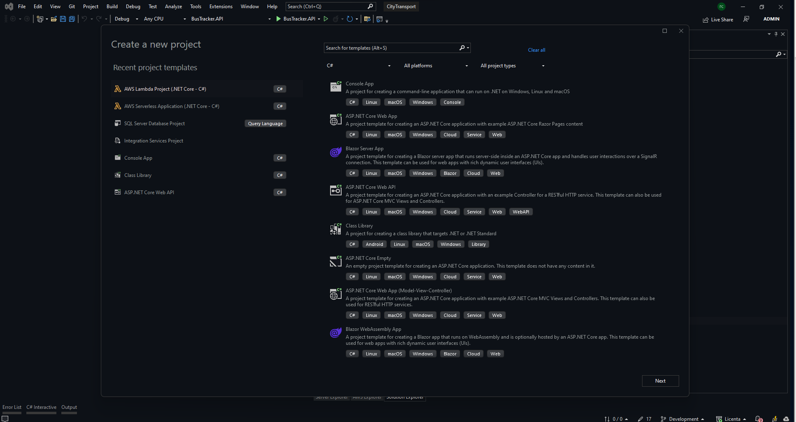
- Figure 16 Visual Studio Control Panel

The choice of Visual Studio as the development platform was determined by a number of factors. One of these was the need to easily integrate AWS services within the application. Visual Studio provides built-in support for AWS, including an AWS Toolkit for Visual Studio that allows developers to embed or run code in AWS environments, interact with databases and other AWS resources, modify settings and configurations, and perform other AWS-related operations.(Figure 16)

Additionally, the Microsoft SQL Server database used in our application could be easily integrated into Visual Studio, allowing data to be created, queried, and managed directly within the IDE. Connecting to SQL Server was facilitated through Server Explorer, a panel in Visual Studio that allows developers to view and manipulate databases to which they connect.

VS Code
VS Code is a source code editor developed by Microsoft that includes support for debugging, integrated Git control, syntax highlighting, smart code completion, snippets, and code refactoring. It is free and open source, although the official version of the binaries is proprietary software and default telemetry is enabled. To develop Alexa skills, the Alexa Skills Kit (ASK) extension was used in VS Code. This facilitated the rapid creation, testing and deployment of Alexa skills within the application, enabling a more efficient and faster development cycle. (Figure 17)
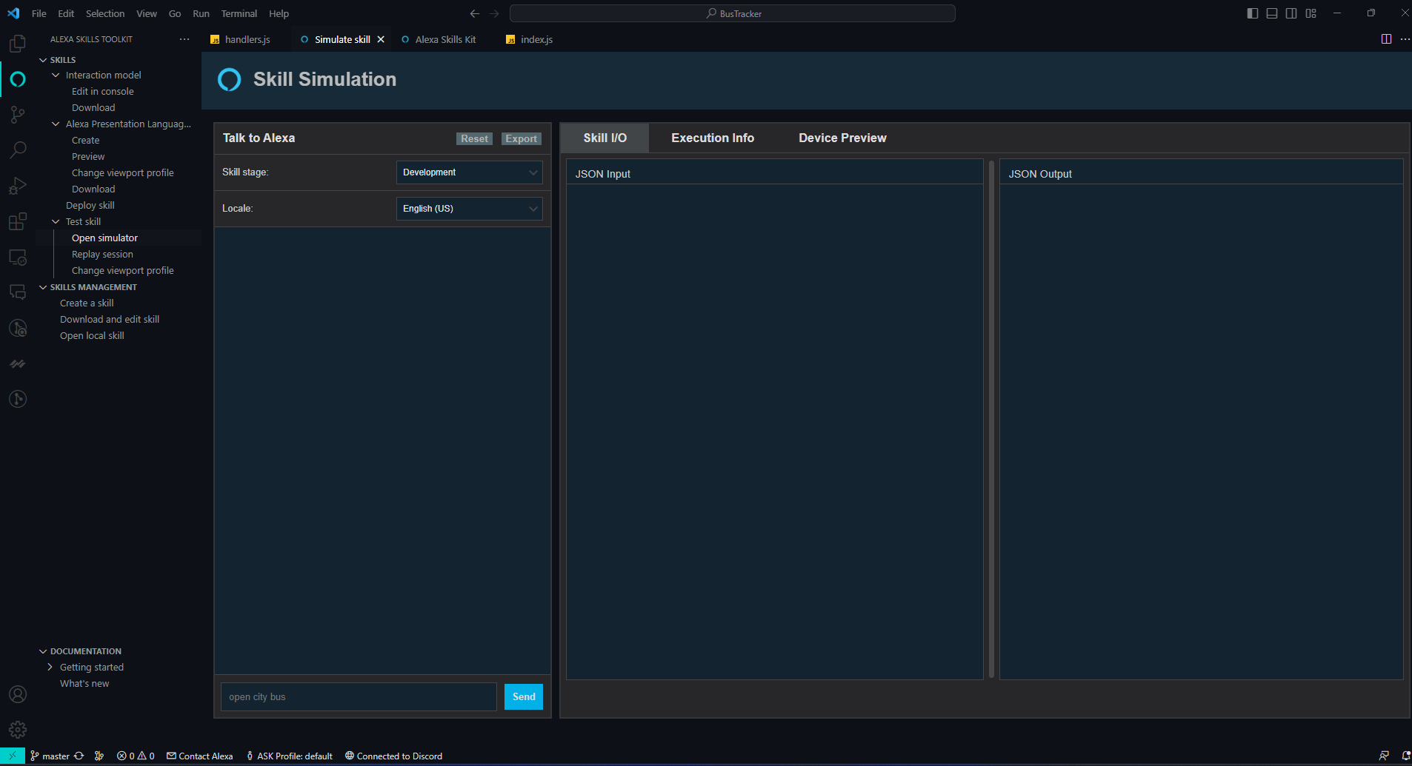
- Figure 17 Vs Code Alexa Skill Kit Extension that support application development and testing

Amazon Alexa Developer Console
The variety of tools available to Alexa developers assist in every step of creating a new Alexa skill, whether it's setting up the interaction model, developing the service associated with the skill, deploying, testing, or simulating the skill. There are tool variants to suit different developer preferences, offering options for either those who prefer a graphical interface or those who gravitate towards a command-line and editor-based environment.

The Amazon Alexa Developer Console is a single interface that allows developers to create, verify, and launch Alexa skills. It provides a diverse set of tools for creating sophisticated and natural voice interactions, managing skill configurations, manipulating the interaction model, and evaluating the skill. In the context of the application developed in this project, the Amazon Alexa development console was vital to incorporate Alexa capabilities and facilitate voice interaction with users.

The Alexa Development Console is the integrated environment for Alexa development, structured as a web application. It provides guidance and support, making it the most accessible way to get started with Alexa development, especially for beginners.

Key features of the Alexa Development Console are accessible through various tabs, including the Build, Test, Deploy, Certification, and Analysis tabs. (Error: Reference source not found)
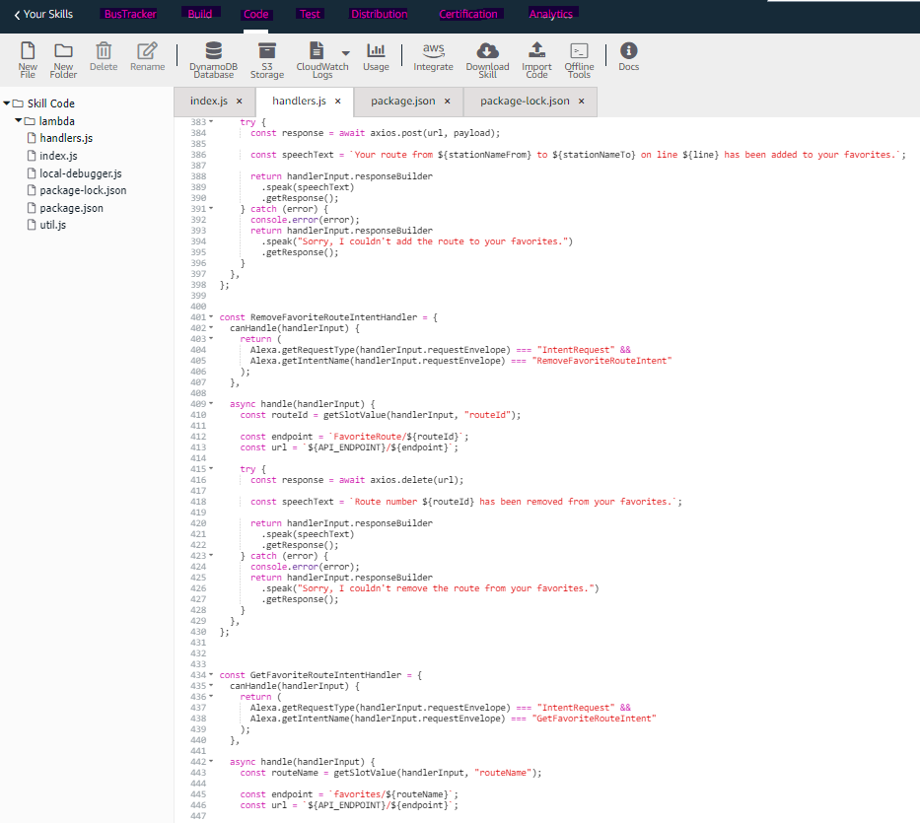
- Figure 18 Alexa Developer console and the features via Tabs

Microsoft Sql Server
Microsoft SQL Server, a relational database management system developed by Microsoft, played a vital role in my project. This database system is a software tool that aims to store and retrieve data at the request of other software applications, regardless of whether they are running on the same computer or on another networked drive (including the Internet). In the context of the application we developed, Microsoft SQL Server was responsible for managing and preserving data, ensuring that information is saved in a secure and efficient way and is available when needed. This was crucial to ensure the efficiency and reliability of the application.

My decision to use Microsoft SQL Server was motivated by the fact that I used a considerable number of Microsoft technologies in this project. I found this to provide tighter integration with the development environment I used. By using a coherent technology ecosystem, we were able to optimize the workflow and ensure better compatibility between the different components of the application. Choosing Microsoft SQL Server was therefore a logical step in building a robust and efficient project, while supporting a fluid interaction between the various elements of the application.

Chapter 9: Application Development and Implementation – 15 pagini

Application hardware components
The Alexa platform's scope extends to the manufacturers of physical hardware devices that incorporate a voice interface. There are certain essential prerequisites for devices to be Alexa-enabled. Perhaps the most recognizable Alexa-equipped hardware device is the Amazon Echo, featuring a speaker, microphone, and internet connectivity. However, a variety of other device types, such as televisions or cars, are also feasible. The advantage for hardware manufacturers who participate in the Alexa platform by creating Alexa-enabled devices is that they aren't required to develop comprehensive voice services and sophisticated voice recognition capabilities independently. Instead, they can benefit from the expanding suite of voice applications within the Alexa ecosystem.

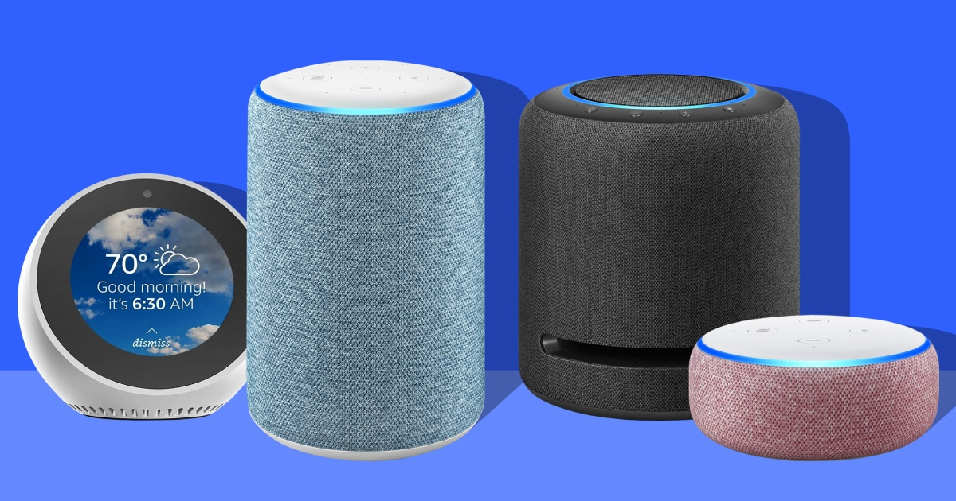 | 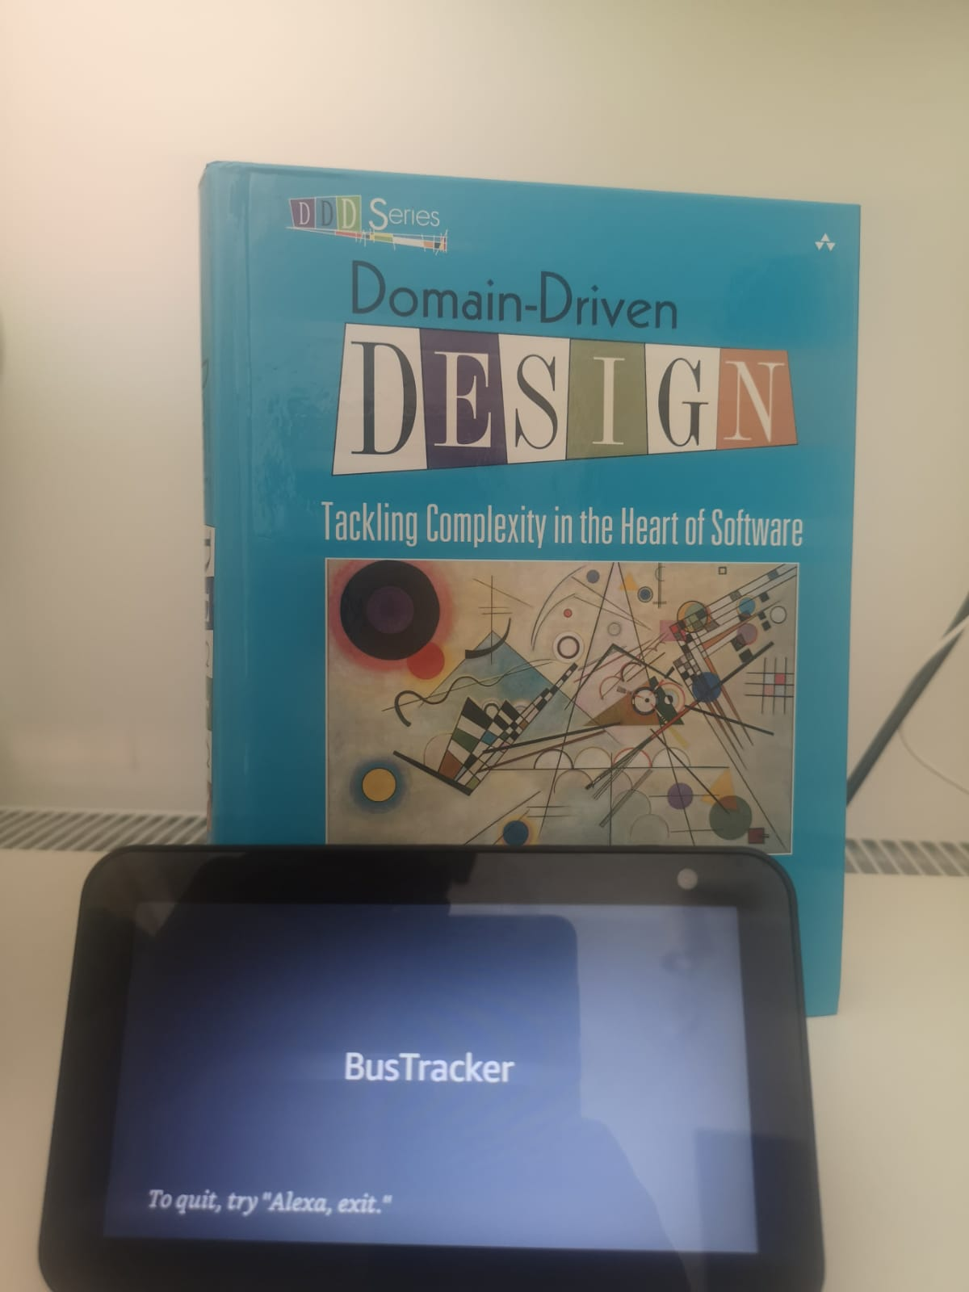  - Figure 19 Alexa Echo Show

In the process of developing and refining this application, an essential part of the process was testing it using Amazon's Echo Show device. The Echo Show, which is a part of Amazon's series of Alexa-enabled smart speakers, offered a unique platform to test the application due to its integration of both visual and audio capabilities.

The Echo Show, with its vibrant screen and high-quality speaker, offers users a multi-modal experience that combines visual information with voice responses from Alexa. This unique combination provides an ideal environment for testing applications that aim to offer users a richer, more interactive experience.

During the testing phase, the Echo Show's screen proved to be incredibly useful, providing a visual representation of the application's responses and actions, thus enhancing the overall user experience. For instance, the screen could display bus arrival times, route maps, or even traffic updates, providing an added layer of information and convenience for users.

Furthermore, Echo Show's voice control capabilities made it possible to thoroughly test the application's voice interaction model. It ensured that the app responded accurately to voice commands, making the user experience smooth and efficient.

The device's inbuilt capabilities, like video calling, also provided an opportunity to experiment with a broader range of the application's features. For instance, users could communicate with customer support or share live updates with other users.

Testing the application on the Echo Show also offered insights into how users interact with voice-user interfaces in a real-world context. This knowledge was invaluable for refining the application, enhancing its usability, and ultimately ensuring it delivered a truly user-centered experience.

What is echo show?

The Alexa Echo Show is a smart home device from Amazon that combines the power of voice-controlled artificial intelligence with a visual display. The Echo Show is a part of Amazon's Echo line of products, all of which feature Amazon's AI assistant, Alexa.

Key features of the Echo Show include:

Visual Display: Echo Show features a vibrant touch screen that complements Alexa's voice responses with visual elements. This could include displaying the current weather, playing videos, showing recipe instructions, making video calls, displaying song lyrics, and much more.

Voice Control: Just like other Echo devices, the Echo Show can be controlled entirely by voice. It can answer questions, play music, control smart home devices, set timers or reminders, make calls, and more.

Video Calling: The Echo Show has a built-in camera and can make video calls to other Echo Show devices, or to anyone with the Alexa app on their smartphone.

Smart Home Hub: Echo Show can act as a hub for your smart home devices. It can connect to and control many different devices, including light bulbs, door locks, and thermostats. With compatible devices, you can even use the screen to view live feeds from security cameras or doorbell cameras.

Entertainment: The Echo Show can stream music from a variety of sources, and with the screen, it can also play TV shows, movies, and other video content.

Overall, the Echo Show combines the voice-controlled convenience of Alexa with the added benefit of visual information, enhancing user interaction and accessibility. It's another step towards a more integrated and interactive smart home experience.

Application Development Process
The development of the application was a dynamic and iterative process that started with the identification of use cases and then moved onto technical implementation. Here, we'll outline the steps involved in the creation of the application.

9.2.1 Identification of Use Cases: The first step in the development process was identifying the key use cases for the application. These use cases represented the functional requirements of the application and were based on the needs and preferences of the users. For example, one of the use cases was to allow users to ask for the next bus times from a particular station. This involved conversing with Alexa to receive real-time updates on bus schedules.

Use Case for Setting a Favorite Route

Actors: User, Voice User Interface (VUI) Application

Precondition: The user has the VUI application installed and set up on their device.

Main Flow:

The user invokes the VUI application by saying the wake word. In our case the Skill Invocation Name is “city bus”.
The VUI application acknowledges and prompts the user for a command.
The user requests to set a favorite route by saying something like, "Set my favorite route from [Location A] to [Location B]."
The VUI application processes the command, confirming the details of the locations and the route.
The VUI application saves this route as the user's favorite.
The VUI application provides vocal feedback to confirm that the route has been set as a favorite.
Postcondition: The user's favorite route has been set in the VUI application.

Exception Paths:

If the VUI application does not understand the locations provided by the user, it will prompt the user to repeat or clarify the command.
If there is no viable public transportation route between the two locations, the VUI application will inform the user and ask for alternative locations.

9.2.2 Technical Implementation
The technical implementation involved creating the software that would drive the application. This was done using the Alexa Skills Kit (ASK) and the .NET framework for backend development.

The backend was structured using a three-layer architecture following principles from Chris Evans' Domain-Driven Design book. It had a core layer consisting of models and interfaces, an infrastructure layer with a data access layer implementing the repository pattern and employing Entity Framework and migrations, and an ASP.Net API layer with MVC, Controllers, and DTOs. This structure allowed for a highly modularized and scalable backend.

The Alexa code was also organized into different handlers for each of the use cases, making the code more maintainable and easier to extend. Each handler was responsible for handling a specific user intent, such as getting bus times or adding a route to favorites.

The API calls to the backend were designed to be RESTful, making the system flexible, scalable, and stateless. This was achieved by hosting the .NET API on an AWS Lambda function, which was housed within a Virtual Private Cloud (VPC) for added security. The Alexa skill was also hosted on an AWS Lambda function, enabling efficient communication between the two.
Integration with AWS Services: The system was integrated with various AWS services like RDS for database management, S3 for storage, and AWS Lambda for serverless computing. This allowed the system to leverage the scalability, reliability, and security features of the AWS platform.

The application was extensively tested on the Amazon Echo Show, which offered a unique platform for testing because of its integration of visual and audio capabilities. This testing phase ensured that the app responded accurately to voice commands and that the visual elements enhanced the overall user experience.

9.2.3 Steps for Setting Up Invocation Name, Intents, Dialog, Slots (Client Side)

To create an effective Alexa skill, we must define certain key elements, including the invocation name, intents, dialog model, and slots. This setup enables the skill to understand and respond to user commands accurately.

Designing the VUI: This involved creating a conversation model for the interactions between the user and Alexa. The goal here was to make the conversation as natural and intuitive as possible, using familiar phrases and language.

Setting up the Invocation Name: The invocation name is the word or phrase that users say to activate your skill. It should be easy to pronounce and remember. To set it up, navigate to the "Skill Information" tab in the Alexa Developer Console, enter the invocation name (e.g., "city bus") in the provided field, and save your changes.

Defining Intents: Intents represent actions that fulfill a user's spoken request. They include built-in intents provided by Alexa (like AMAZON.CancelIntent or AMAZON.HelpIntent) and custom intents that you define (like AddFavoriteRouteIntent or NextBusTimeIntent). Create new intents in the "Build" section of the developer console (Figure 20) , under the "Intents" tab. Specify the intent name and create a set of sample utterances - phrases that users might say to express the intent.

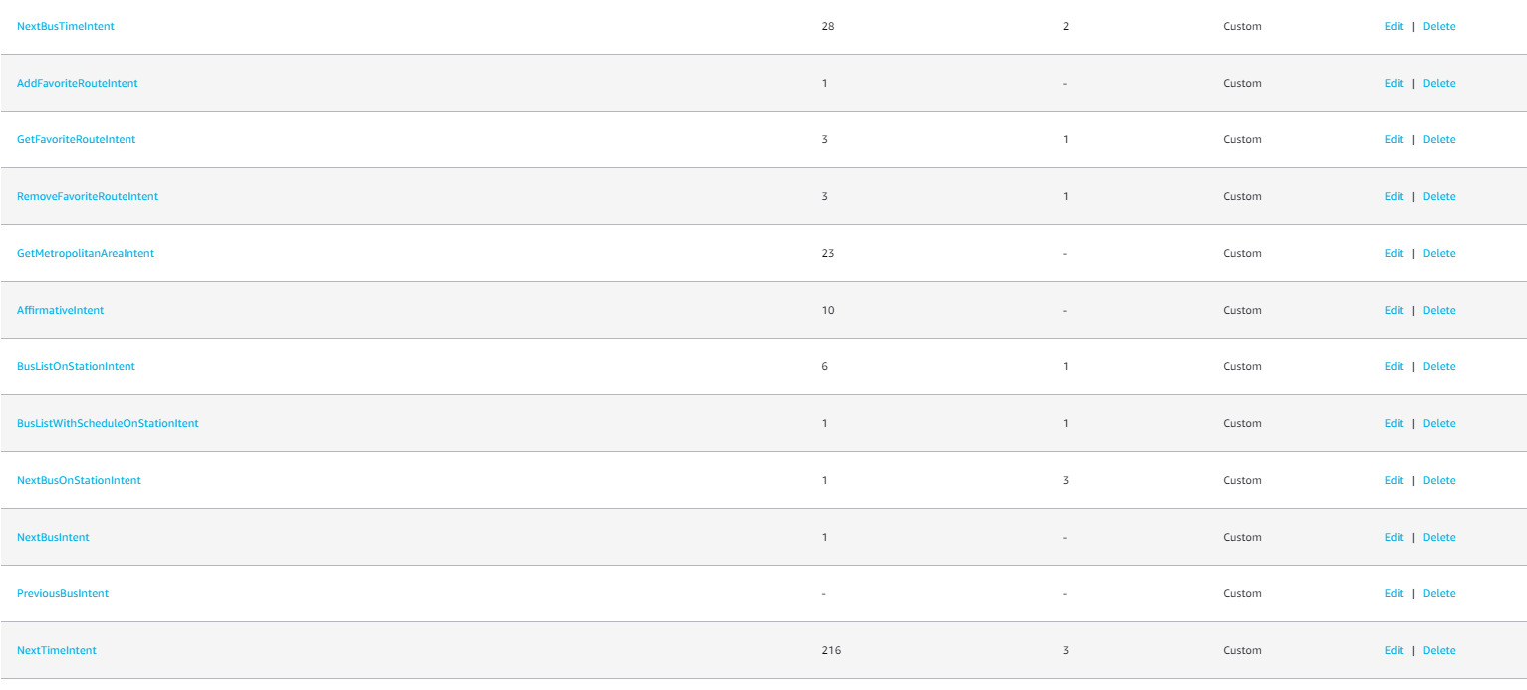
- Figure 20 Intents in Alexa Developer Console

Creating a Dialog Model: A dialog model guides the conversation between Alexa and the user, usually to collect specific information required to fulfill an intent. Under each intent, you can define "Slots" and "Slot Types" - slots are variables that represent a value in the user's utterance, and slot types define the kind of data the slots can accept. For example, for the AddFavoriteRouteIntent, you may have slots for LocationA and LocationB, both of which use the slot type AMAZON.US_CITY. You can also configure prompts and confirmations for each slot to create a more conversational interaction.
Handling the Dialog Delegation: The Alexa service uses dialog management to handle multi-turn conversations for us, delegating the conversation flow. When a user invokes an intent that's configured for dialog management, Alexa drives the conversation by prompting the user for slot values or confirmations, managing ambiguous input, etc.

Uterances:
Utterances in Alexa skill development represent the spoken phrases that users might say to interact with the skill. They map the human language into intents that the Alexa service can understand and act upon.

To train Alexa, developers provide a set of sample utterances for each intent. This set doesn't need to contain every possible phrase a user might say (which would be impossible to achieve) but should instead include a variety of examples that represent different ways users might express each intent. (Figure 21)

These utterances form the basis of the machine learning model that Alexa uses to interpret user speech. During the training process, Alexa learns to recognize not only these exact phrases, but also similar phrases it has never heard before. This allows Alexa to understand a wide range of possible user inputs.

The more diverse and representative your sample utterances are, the better Alexa will perform at understanding and responding to user requests. However, it's important to note that utterances should be representative of natural, spoken language, as Alexa skills are primarily intended to be used via voice interaction.

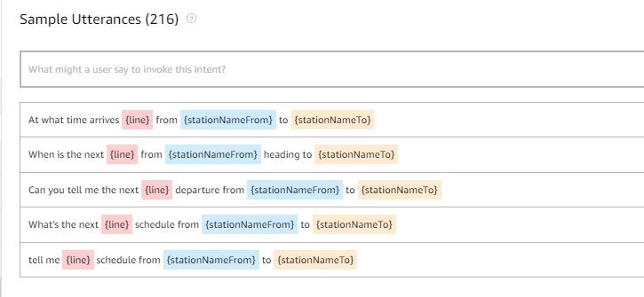
- Figure 21 Dialog Model with 216 utterances

Building and Testing the Skill: Once you have configured your invocation name, intents, dialog, and slots, click "Build Model" to train Alexa with the new information. After the model has been built, test your skill in the "Test" section of the developer console, or directly on your Alexa device.

Slots:
Slots in Alexa Skills development act as variables that capture user input to be used by the skill. Each slot corresponds to a list of potential values, and Alexa uses machine learning to match the spoken words with these values.
There are two types of slots: built-in and custom.

Built-in slots are provided by Alexa and support many common data types, such as dates, times, numbers, and more. The AMAZON.US_FIRST_NAME that you used is a built-in slot and it's designed to recognize and capture a common set of U.S. first names. When a user speaks a first name, Alexa attempts to match it to the list of known first names.

Custom slots, on the other hand, are defined by you, the developer. They are useful when you want to capture a specific set of values that aren't covered by Alexa's built-in slots. In your case, you've created custom slots for BusLine and BusStation.
For each of these custom slots, you would provide a list of valid values. For example, the BusLine slot might include values like "Route 1", "Route 2", "Route 3", etc., and the BusStation slot might include names of bus stations that your application supports.
When a user mentions a bus line or station in their command, Alexa will attempt to match the spoken words with the slot values you've provided.

Overall, slots make it possible for your skill to handle a wide variety of user inputs and respond appropriately, greatly increasing the skill's flexibility and usability.

Handlers

In the context of Alexa Skills, a handler is a piece of code that performs specific actions when triggered by certain events, like a user saying a particular phrase or command. Handlers can interpret and respond to user input, carry out tasks, interact with external systems (like APIs), and more.
In the provided code, NextBusTimeHandler is a handler for an Alexa skill. It's an object with two key methods: canHandle and handle.

The canHandle function is where the skill determines whether or not it can handle the incoming request. In this case, it's looking for an IntentRequest with the name NextTimeIntent.(Figure 22.1, Figure 22.2)

The handle function is called if canHandle returns true. This function is responsible for carrying out the actions of the intent. It first extracts the slot values for "line", "stationNameFrom", and "stationNameTo" from the user's spoken command using the getSlotValue helper function
.
These values are then stored in the session attributes. Session attributes in Alexa Skills are a way to save and access data that needs to persist throughout a user's session with the skill.
The handle function then constructs a URL for the API endpoint, which includes the extracted slot values as path parameters.
An HTTP GET request is made to this API endpoint using the axios library. If the request is successful, the response will include the time until the next bus arrives.
The response data is then used to construct a message to be spoken to the user. If the time until the next bus is greater than or equal to 60 minutes, the message includes the time in hours and minutes. Otherwise, it's given in minutes.
The message also includes a question asking the user if they would like to add the route to their favorites. If the user responds with "yes", this could trigger another intent to handle the action of adding the route to the favorites.
If there is an error with the API request, an error message is spoken to the user.

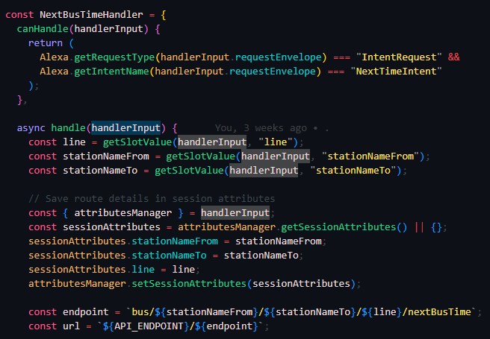
Figure 22.1 Handler that provides the time until the next bus arrives for a specified route.

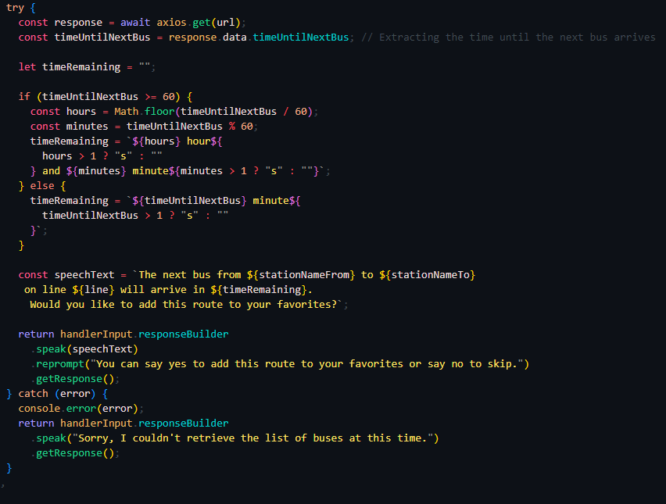
Figure 23.2 Handler that provides the time until the next bus arrives for a specified route.
This handler thus forms an essential part of the skill, interfacing with the user to capture their requirements, interacting with the backend API to retrieve information, and providing the user with a timely response. It showcases a common use case for voice user interfaces: providing real-time, dynamic information in a conversational manner

9.2.3 .Net API - Backend

The backend of the VUI application will need to include functionality to store user-specific data, such as favorite routes.
As part of the application's development, one of the key workflows I implemented involved a harmonious interaction between the Alexa Skill Handler and the backend infrastructure. Upon a user's request to save their favorite route, the Alexa Skill Handler triggers an HTTP request to our backend. This request, usually in the form of a POST or PUT method, carries the essential data— the particulars of the favorite route in this case.

Once the backend receives this request, it proceeds to process the data, subsequently appending the favorite route details to the designated table in our SQL Server database. A setup of this kind comes with numerous advantages.

Firstly, the use of a relational database like SQL Server allows for efficient tracking, management, and analysis of the user's favorite routes. This functionality is especially valuable in offering users a tailored experience, enhanced by the capabilities of the Alexa Skill.

The backend implementation for this feature would require several steps, outlined below:

Database Update: First, update your database schema to include a favorites table that will associate each user with their favorite routes. The table should include fields such as UserId, RouteId, RouteName, StartPoint, EndPoint, and any other relevant information about a route.

Create an API Endpoint: Create an API endpoint that will allow users to create, read, update, and delete favorite routes. Use HTTP methods like POST (to create a new favorite), GET (to retrieve a list of favorites), PUT or PATCH (to update an existing favorite), and DELETE (to remove a favorite).

Implementing Business Logic: In your application's business logic layer, you'll want to implement methods that interact with the new database table. These methods should handle tasks like adding a new favorite route, retrieving all favorite routes for a user, updating an existing favorite route, and deleting a favorite route.

Integration Backend with Client Side

Integrate with VUI: In the portion of your code that interacts with the VUI (in this case, Alexa), update the logic to include interactions around favorite routes. This will include intents to handle the creation, retrieval, updating, and deletion of favorite routes. Ensure that these new intents are properly integrated into your interaction model.

Testing: Finally, thoroughly test the new feature. This includes unit testing your business logic methods, testing the API endpoint with tools like Postman, and user acceptance testing with the actual VUI. Make sure to cover edge cases, such as what happens when a user tries to add a sixth favorite route, or if they try to update or delete a route that doesn't exist.

When a user sets a favorite route, the application should save this information in the database. It will involve storing two main data points: the starting point (Location A) and the endpoint (Location B). This data should be linked with the user's account so that it can be accessed across various devices.

The VUI application should also have functionality to recognize commands related to favorite routes. This will involve natural language processing to identify when the user wants to set a favorite route, as well as the specific locations involved.

After the route is set as a favorite, the user should be able to access it with a simple command like, "What's my favorite route?" or "Navigate my favorite route." The VUI application should then retrieve the route from the database and provide the necessary information.

Structure of the database
Our database structure plays a pivotal role in the functioning of the application. This chapter will delve into the specifics of the structure, explaining how it enables efficient storage and retrieval of data.

The database we used for this project is SQL Server, a relational database management system (RDBMS) by Microsoft. As an RDBMS, SQL Server allows us to structure our data into distinct tables, each containing data about a specific topic. The benefit of this approach is that it promotes data consistency, reduces redundancy, and makes querying for data significantly more efficient.

It's important to note that by using SQL Server, we're able to leverage its powerful querying capabilities. This makes it easier to retrieve data, especially when dealing with complex queries. Also, its ACID (Atomicity, Consistency, Isolation, Durability) compliance ensures reliable processing of transactions, which is essential for the integrity of our application's operations.

9.3.1 Designing a City Transport Database
In order to effectively manage the complex interdependencies of public transportation in a city, the creation of a comprehensive and organized database is imperative. My goal was to design a database that could not only encapsulate the crucial elements of a city's transportation infrastructure but also allow for intuitive access and manipulation of the data.

The first step in creating this database was the identification and establishment of the relevant entities, which subsequently translated into the database tables. These entities include Area, Bus, BusStation, City, MetropolitanArea, Schedule, and FavoriteBusRoute.(Figure 24)

The Area table represents specific regions within a city, with the primary identifier being AreaId, and each area is associated with a particular city via the CityId foreign key.

The Bus table lists all buses in operation, each identified by a unique BusId. The BusName column provides a human-friendly identifier for each bus.

The BusStation table is vital for defining the many stations around the city. Each station is linked to a specific area using the AreaId foreign key, thus establishing a clear geographical hierarchy within the database.

The City table includes all cities covered by the transportation system. Each city is part of a larger metropolitan area, which is signified by the MetropolitanAreaId foreign key.

In a metropolitan city, several cities co-exist and are interconnected. The MetropolitanArea table caters to this broader geographical categorization. Each metropolitan area can include several cities, and this relationship is represented in the City table.

The Schedule table forms the core of the transportation system, listing all bus schedules. Each entry is tied to a specific bus and bus station, represented by the BusId and StationId foreign keys, respectively.

Lastly, the FavoriteBusRoute table stores user-specific data regarding preferred bus routes. While it is not directly connected to other tables via foreign keys, logical connections exist, such as BusName likely referring to Bus.BusName, and StationFrom and StationTo possibly connecting to BusStation.StationName.

The relationships between these tables form a complex web of data interdependencies, accurately reflecting the intricacies of a city's public transportation system. This structure ensures data normalization and integrity, preventing unnecessary data duplication and fostering efficient data management.

During the conceptualization and implementation of this database, it was important to consider not only the current requirements but also potential future needs. As such, the database design provides a flexible and scalable solution, ready to accommodate the evolving demands of a dynamic urban environment.

Designing this city transport database was a challenging and enriching task, providing valuable insights into the interconnected nature of public transportation systems and the role of structured data management in facilitating efficient operations. With this robust and versatile database, the city's transportation management can leverage the power of organized data to make informed decisions, optimize routes, improve services, and ultimately enhance the commuter experience.
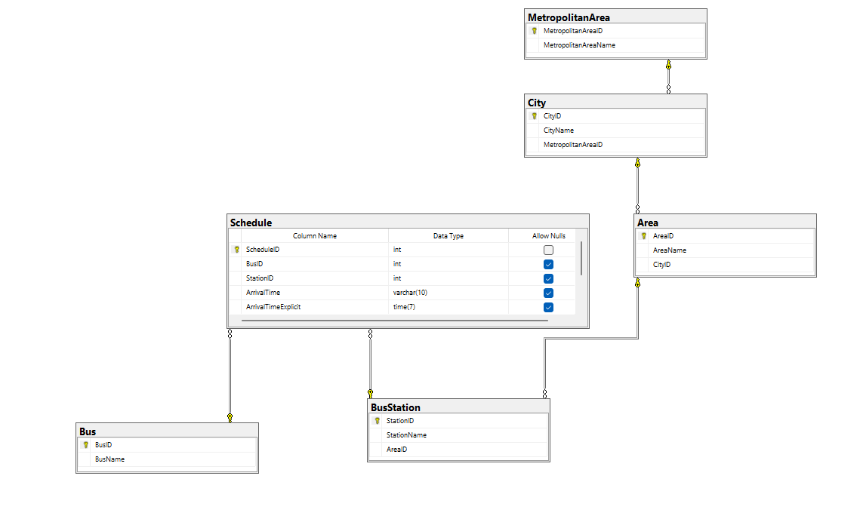
- Figure 24 Database Schema

Application User Guide

Bus Tracker Guide: User Manual
Welcome to your user manual for the City Bus Alexa skill! This guide is designed to provide you with step-by-step instructions on how to navigate and make the most out of our Alexa skill on your Echo Show device.

Getting Started
Before you can start using the Bus Tracker skill, you'll need to activate it.
Here's how:
Say "Alexa, open city bus" to launch the skill.
How to Use the App
Once the app is activated, you can use the following commands:
    - Saying Hello:
Start by saying "Hello" to the app by invoking "Alexa, say hello to city bus". The HelloWorldIntentHandler will respond back with a greeting.
    - Check Bus Schedule:
To retrieve a list of buses on a particular station with their schedules, say "Alexa, ask city bus for the bus schedule at [station name]". The BusListWithScheduleOnStationHandler takes over here, providing you with detailed information about the buses available at the specified station.
    - Find Next Bus:
To find the next bus arriving at a specific station, use the phrase "Alexa, ask city bus when the next bus is at [station name]". The NextBusOnStationHandler will give you the details of the next bus scheduled to arrive at your station.
    - Get Arrival Time of Next Bus:
If you want to find out how much time is left for the next bus on a certain route, you can say "Alexa, ask city bus when the next bus from [Location A] to [Location B] on line [Line number] will arrive". The NextBusTimeHandler will then provide you with the time remaining for the next bus on the specified route.
    - Setting Favorite Routes:
To set a favorite route, you can use the command "Alexa, ask city bus to set my favorite route from [Location A] to [Location B]". This command triggers the AddFavoriteRouteIntentHandler, which then saves your specified route as a favorite.
Removing Favorite Routes:
If you wish to remove a route from your favorites, you can say "Alexa, ask city bus to remove my favorite route from [Location A] to [Location B]". The RemoveFavoriteRouteIntentHandler will then remove the specified route from your favorites.
    - Retrieving Favorite Routes:
To retrieve your favorite routes, simply say "Alexa, ask city bus to show my favorite routes". The GetFavoriteRouteIntentHandler will provide you with a list of all your favorite routes.
    - Check Buses for Metropolitan Area:
To know the buses available in a metropolitan area, use the command "Alexa, ask city bus about buses in the [metropolitan area]".
The MetropolitanAreaHandler will then give you a list of available buses in the specified metropolitan area.
Remember, you can always say "Alexa, help" while in the City Bus skill to get a list of commands you can use. Enjoy your Bus Tracker Alexa skill!

Chapter 10: Future Development Perspectives
The City Transport Alexa Skill has already provided a great deal of value to its users, offering detailed, convenient information about public transport networks. However, the possibilities for further development are significant. In this presentation, we will explore several directions for future growth and improvement.

    - Real-Time Data Integration To offer the most accurate and up-to-date information about public transportation, we can collaborate with transportation service providers. This involves obtaining and integrating real-time data from their systems to provide a more accurate and personalized user experience. This could include live updates on bus schedules, delays, or cancellations, providing users with the most current information possible.

    - Enhanced Functionalities As users seek new and more advanced features, there are opportunities to add functionality such as interactive maps and alternative route suggestions. Interactive maps could visualize bus routes, helping users understand their journey more clearly. Additionally, suggesting alternative routes in case of disruptions could significantly improve the user experience, providing flexibility and resilience.

    - Integration with Other Transport Systems Currently, our application focuses on bus transportation. However, by integrating data from other modes of public transport—like trams, subways, or ferries—we could offer a more comprehensive service. This would allow users to plan their journey seamlessly, even when it involves multiple modes of transportation.

    - Expansion to Other Platforms Beyond Alexa, the City Transport application could be developed on other platforms such as Google Assistant, Siri, and mobile applications. This would enable users to access public transport information regardless of the platform they use, making the service more widely accessible.

    - Use of Google APIs for Locations Google's powerful APIs could be utilized to improve location-based services. This includes Google Maps API for displaying routes, and Google Places API for autocomplete suggestions when users are entering their destination or location. This would significantly enhance the user experience in terms of ease of use and accuracy of information.

    - Romanian Language Model Although the application currently understands Romanian with some difficulty, efforts could be made to improve language recognition and processing. Training the language model on more Romanian speech data could enhance the application's ability to understand and respond to Romanian commands.

    - From Prototype to Full-Fledged Application While the current City Transport skill is a prototype, it is clear that it has immense potential as a full-fledged application. Through the above enhancements, and by continually refining and testing the application based on user feedback, we can transition the skill from a prototype into a regular application. This would entail significant work on enhancing reliability, scalability, and performance to handle a larger user base.

In conclusion, the City Transport Alexa Skill holds great promise for further development. By focusing on real-time data, expanding functionalities, integrating with other systems, and refining the language model, we can take the application to the next level, offering a seamless, comprehensive, and user-friendly solution for public transportation information.

Conclusion
In my graduate work, I took a deep dive into a fascinating crossroad – where public transportation meets artificial intelligence. My journey was centered around creating a voice-activated City Transport Alexa Skill, a practical answer to a real-world problem.

At the outset, I aimed to define why this topic matters, both in theory and practice. I found that combining the essential public transport system with cutting-edge technology is not only innovative but also necessary in our fast-changing world. This realisation was the cornerstone of my project.

Throughout my work, I put in my best efforts to make unique contributions to the field. From pinpointing areas for improvement in public transport to designing and executing a feasible solution, my distinct perspective and skills were at play.

An important part of my work was dedicated to research, which formed the backbone of my project. I surveyed current trends and compared voice interfaces with graphical ones, which was a real eye-opener. This comparison showed a clear shift in technology trends, underscoring the relevance of the Alexa Skill I was developing.

I also delved into the exciting world of the Internet of Things (IoT) and how it can benefit public transport. I learned a lot about the pros, cons, and future possibilities of IoT, which reminded me of how connected our world is becoming.

The process of building the application from scratch was a challenging yet rewarding journey. I had to consider a range of factors, from the overall architecture and functionality to complex aspects like integrations and machine learning processes. I made sure to prioritize security, privacy, and mechanisms for collecting feedback and improving the app – all crucial for a successful application.

I utilized various technologies, like ASP.Net, Node.js, Alexa Skill Kit, Amazon Web Services, and Microsoft SQL. Along with development tools like Visual Studio, VS Code, and Amazon Alexa Developer Console, these technologies showed me the power of modern development tools.

The closing part of my paper focused on the development and implementation of the app, detailing everything from hardware components to the database structure. I also created a user-friendly guide to ensure that anyone, technical or not, could easily interact with the Alexa Skill.

In summary, this graduate paper was a fulfilling journey that showed me how research can be effectively transformed into a practical solution. I made a significant stride in the realm of public transport, boosting user experience through voice-activated technology. Looking back, I see my work as a valuable resource for anyone interested in the future of public transport and artificial intelligence, and I look forward to continuing to contribute to this exciting field.

Concluzie
În lucrarea mea de absolvire, am realizat o analiză profundă la o intersecție fascinantă - acolo unde transportul public întâlnește inteligența artificială. Călătoria mea a fost centrată în jurul creării unui Skill Alexa de Transport Urban activat vocal, un răspuns practic la o problemă reală.

La început, am avut ca scop să definim de ce acest subiect contează, atât din punct de vedere teoretic, cât și practic. Am constatat că combinarea sistemului esențial de transport public cu tehnologia de ultimă generație nu este doar inovatoare, ci și necesară în lumea noastră în schimbare rapidă. Această realizare a fost piatra de temelie a proiectului meu.

Pe parcursul muncii mele, mi-am pus cele mai bune eforturi pentru a aduce contribuții unice în domeniu. De la identificarea zonelor de îmbunătățire în transportul public până la proiectarea și executarea unei soluții fezabile, perspectiva și abilitățile mele unice au fost la lucru.

O parte importantă a muncii mele a fost dedicată cercetării, care a constituit coloana vertebrală a proiectului meu. Am studiat tendințele actuale și am comparat interfețele vocale cu cele grafice, care au fost o adevărată descoperire. Această comparație a arătat o schimbare clară în tendințele tehnologice, subliniind relevanța Skill-ului Alexa pe care îl dezvoltam.

De asemenea, m-am aprofundat în lumea fascinantă a Internetului Obiectelor (IoT) și cum acesta poate beneficia transportul public. Am învățat multe despre avantajele, dezavantajele și posibilitățile viitoare ale IoT, ceea ce mi-a amintit de cât de conectată devine lumea noastră.

Procesul de construire a aplicației de la zero a fost o călătorie provocatoare, dar recompensatoare. Am avut în vedere o serie de factori, de la arhitectura generală și funcționalitate până la aspecte complexe, cum ar fi integrările și procesele de învățare automată. M-am asigurat că am prioritizat securitatea, confidențialitatea și mecanismele de colectare a feedback-ului și îmbunătățirea aplicației - toate esențiale pentru o aplicație de succes.

Am utilizat diverse tehnologii, precum ASP.Net, Node.js, Alexa Skill Kit, Amazon Web Services și Microsoft SQL. Alături de instrumente de dezvoltare precum Visual Studio, VS Code și Amazon Alexa Developer Console, aceste tehnologii mi-au arătat puterea instrumentelor moderne de dezvoltare.

Partea finală a lucrării mele s-a concentrat pe dezvoltarea și implementarea aplicației,

detaliind totul, de la componentele hardware la structura bazei de date. De asemenea, am creat un ghid prietenos pentru utilizator, pentru a se asigura că oricine, tehnic sau nu, poate interacționa ușor cu Skill-ul Alexa.

Rezumând, această lucrare de absolvire a fost o călătorie împlinitoare care mi-a arătat cum cercetarea poate fi transformată eficient într-o soluție practică. Am făcut un pas semnificativ în domeniul transportului public, îmbunătățind experiența utilizatorului prin tehnologia activată vocal. Uitându-mă înapoi, văd munca mea ca o resursă valoroasă pentru oricine este interesat de viitorul transportului public și al inteligenței artificiale și abia aștept să continui să contribui la acest domeniu fascinant.

Bibliography

Boldare. What is voice user interface. Retrieved from https://www.boldare.com/blog/what-is-voice-user-interface/
UXPin. Voice User Interface. Retrieved from https://www.uxpin.com/studio/blog/voice-user-interface/
Online Engineering & Internet of Things Proceedings of the 14th International Conference on Remote Engineering and Virtual Instrumentation REV 2017, held 15-17 March 2017, Columbia University, New York, USA
Simplilearn. Artificial Intelligence Tutorial. Retrieved from https://www.simplilearn.com/tutorials/artificial-intelligence-tutorial/ai-vs-machine-learning-vs-deep-learning?source=sl_frs_nav_playlist_video_clicked
Statista. Internet of Things (IoT) - statistics & facts. Retrieved from https://www.statista.com/topics/2637/internet-ofthings/#topicOverview
Demand Sage. 65 Voice Search Statistics For 2023 (Updated Data). Retrieved from https://www.demandsage.com/voice-searchstatistics/#:~:text=General%20Voice%20Search%20Statistics&text=36.6%25%20of%20US%20residents%20 use,users%20in%20the%20year%202021.)
Biehl, M. (2019). Making Money with Alexa Skills: A Developer's Guide.
Evans, Eric. "Domain-Driven Design: Tackling Complexity in the Heart of Software." (2003).
Microsoft Build. Retrieved from https://wikimili.com/en/Microsoft_Build
- https://learn.microsoft.com/en-us/dotnet/core/introduction
PositiWise. The Current Status and the Future of the .NET Framework. Retrieved from https://positiwise.com/blog/the-current-status-and-the-future-of-the-net-framework
Node.js. Retrieved from https://en.wikipedia.org/wiki/Node.js
JetBrains. Setting Up a VPC and RDS on AWS. Retrieved from https://www.jetbrains.com/pycharm/guide/tutorials/django-aws/setup-vpc-and-rds/
Dimensionless. AWS Big Data Prep Course. Retrieved from https://dimensionless.in/aws-big-data-prep-course-why-you-need-it/
AWS. Overview of Amazon Web Services. Retrieved from https://d1.awsstatic.com/whitepapers/aws-overview.pdf .NET. What is .NET?. Retrieved from https://dotnet.microsoft.com/en-us/learn/dotnet/what-is-dotnet Microsoft. (n.d.). Introduction to .NET. Retrieved from https://learn.microsoft.com/en-us/dotnet/core/introduction Microsoft. (n.d.). .NET Languages. Retrieved from https://learn.microsoft.com/en-us/dotnet/fundamentals/languages#c ASP.NET. ASP.NET documentation. Retrieved from https://learn.microsoft.com/en-us/aspnet/core/?view=aspnetcore-7.0 Freeman, E., & Robson, E. (2014). Head First Design Patterns: A Brain-Friendly Guide. Gubbi, J., Buyya, R., Marusic, S., & Palaniswami, M. (2013). Internet of Things (IoT): A vision, architectural elements, and future directions. Future Generation Computer Systems, 29(7), 1645-1660. Botta, A., de Donato, W., Persico, V., & Pescapé, A. (2016). Integration of cloud computing and internet of things: a survey. Future Generation Computer Systems, 56, 684-700. Microsoft. (n.d.). A Tour of C#: Strategy. Retrieved from https://learn.microsoft.com/en-us/dotnet/csharp/tour-of-csharp/strategy Reasons Why .NET Framework is Most Demanded in 2023. LinkedIn. Retrieved from https://www.linkedin.com/pulse/reasons-why-net-framework-most-demanded-2023-/ Appendix A1: Existing Studies - Dorri, A., Kanhere, S., & Jurdak, R. (2017). "Towards an Optimized BlockChain for IoT" - Yashiro, T., Kobayashi, S., Koshizuka, N., & Sakamura, K. (2013). "An Internet of Things (IoT) architecture for embedded appliances" - Chianese, A., & Piccialli, F. (2014). "Designing a Smart Museum: When Cultural Heritage Joins IoT" - Scuotto, V., Ferraris, A., & Bresciani, S. (2016). "Internet of Things: Applications and challenges in smart cities: a case study of IBM smart city projects" - Popović, T., Latinović, N., Pešić, A., Zečević, Ž., Krstajić, B., & Djukanović, S. (2016). "Architecting an IoT-enabled platform for precision agriculture and ecological monitoring: A case study" - Stanislav, M., & Beardsley, T. (2015). "HACKING IoT: A Case Study on Baby Monitor Exposures and Vulnerabilities" - Dorri, A., Kanhere, S., Jurdak, R., & Gauravaram, P. (2017). "Blockchain for IoT security and privacy: The case study of a smart home" - Karakostas, B. (2013). "A DNS Architecture for the Internet of Things: A Case Study in Transport Logistics" - Freeman, E. (2004). Head First Design Patterns. O'Reilly Media. - Roth, C., & Verhulsdonck, G. (2014). Clarity in the Interface in the Age of Ubiquitous Computing. University of Colorado. - Cearley, D. W., Burke, B., Searle, S., Walker, M. J., Claunch, C. D., Smith, D. M., Plummer, D. C., McGee, A. V., Basso, M., McIntyre, A., et al. (2018). Top 10 Strategic Technology Trends for 2019. Gartner Research. - The Architecture of Platforms: A Unified View" by Cusumano, M. A., & Gawer, A. (2002)

